A Novel PSD-Based Approach for Correlating XRD-Derived Phase Evolution and Strength Development in Alkali-Activated Mortars
Optimisation of Alkali-Activated Mortars using Taguchi Analysis
Pratik Kanungo¹, Anush K. Chandrappa², Dinakar Pasla³
¹ Research Scholar, Concrete Technology, School of Infrastructure, IIT Bhubaneswar, Odisha, 752050, India, Email: a23ce09018@iitbbs.ac.in, ORCiD ID: 009000065543143
² Associate Professor, School of Infrastructure, IIT Bhubaneswar, Odisha, 752050, India, Email: akc@iitbbs.ac.in
³ Professor, School of Infrastructure, IIT Bhubaneswar, Odisha, 752050, India, Email: pdinakar@iitbbs.ac.in
Abstract
This study investigates the mechanical and durability properties of geopolymer mortar incorporating sintered lightweight aggregate (SLWA) for potential use in pavement and building applications. Employing the Taguchi method, an L9 orthogonal array was used to systematically design experiments and optimise key parameters influencing mortar performance. Analysis of variance (ANOVA) was conducted to determine the significance and contribution of individual factors, while the signal-to-noise (S/N) ratio was calculated to identify optimal levels for compressive strength and durability indices. X-ray diffraction (XRD) analysis confirmed the formation of geopolymeric gel phases and identified residual crystalline phases, elucidating the reaction mechanisms. Scanning Electron Microscopy (SEM) provided insights into the microstructure, revealing the distribution and bonding characteristics of the geopolymer matrix and SLWA. Results demonstrated that mix design parameters such as alkaline activator concentration, aggregate–binder ratio, and curing regime significantly influenced the strength and microstructure of the mortar. The optimised mix exhibited enhanced compressive strength, improved durability, and a denser microstructure, making it a promising, sustainable alternative for conventional concrete in infrastructure applications.

Keywords: Geopolymer mortar, Alkali Activated, Taguchi Analysis, S/N Ratio.

Introduction
The rapid pace of urbanisation and infrastructure development has resulted in an unprecedented increase in global cement demand. Current estimates indicate that worldwide cement production exceeds 4.1 billion tonnes annually, making cement one of the most widely consumed manufactured materials on Earth (Fayaz et al., 2025). However, the production of ordinary Portland cement (OPC) is highly energy-intensive and environmentally harmful, accounting for approximately 7–8% of global anthropogenic carbon dioxide (CO₂) emissions and nearly 26–27% of total industrial CO₂ emissions (Massoumi Nejad et al., 2025). Recent reports by the International Energy Agency (IEA) and the Global Cement and Concrete Association (GCCA) indicate that the cement sector emitted nearly 1.6 billion tonnes of CO₂ in 2022 alone, with an average emission intensity of approximately 0.6 tonnes of CO₂ per tonne of cement produced (GCCA Forum, 2024). Furthermore, total emissions from the cement industry remain higher than those reported in 2015, indicating that the sector is not currently on track to meet global net-zero targets by 2050 (IEA; IRENA; UNCCHLC, 2023). Consequently, the development of sustainable, low-carbon alternatives to Portland cement has become an urgent necessity to reduce the construction industry's environmental footprint.
In recent years, alkali-activated binders (AABs) have emerged as one of the most promising alternatives to OPC owing to their significantly lower environmental footprint and their ability to utilise industrial by-products as precursor materials. Unlike Portland cement, AABs develop binding characteristics through the dissolution and polycondensation of aluminosilicate-rich precursors in highly alkaline environments, thereby eliminating the need for clinker production and substantially reducing greenhouse gas emissions (Bellum et al., 2025). Previous studies have reported that alkali-activated materials can reduce embodied CO₂ emissions by 40–80%, depending on the precursor source and activator composition, and exhibit excellent mechanical properties, low permeability, and improved chemical resistance (Mancke & Stephan, 2026; R et al., 2026). Furthermore, the ability to incorporate industrial waste materials such as fly ash, ground granulated blast-furnace slag (GGBS), metakaolin, and various agricultural ashes aligns closely with the principles of the circular economy and sustainable construction (Gautam et al., 2024). Consequently, alkali-activated binders have received considerable attention as next-generation cementitious materials for structural and infrastructure applications.
Among the various precursor systems investigated for alkali activation, fly ash (FA) and ground granulated blast-furnace slag (GGBS) blends have demonstrated particularly promising performance due to the complementary characteristics of the two materials (Mehta et al., 2020). Class F fly ash is rich in reactive silica and alumina but possesses low calcium content, which generally results in slower reaction kinetics and delayed strength development under ambient curing conditions (Kucukgoncu & Özbayrak, 2025). In contrast, GGBS contains substantial quantities of calcium oxide and exhibits significantly higher reactivity, promoting rapid dissolution and early-age strength gain (Girish et al., 2026). The simultaneous utilisation of FA and GGBS therefore creates a synergistic reaction environment in which both sodium aluminosilicate hydrate (N-A-S-H) and calcium aluminosilicate hydrate (C-A-S-H) gels are formed. The coexistence of these reaction products produces a denser and more interconnected microstructure, reduces pore connectivity, and substantially enhances the mechanical and durability performance of the hardened binder (El Alouani et al., 2024; Nasr et al., 2026). Several studies have demonstrated that the optimal performance of alkali-activated systems is generally achieved through carefully balanced FA-GGBS proportions, as excessive fly ash content may limit reaction kinetics, whereas excessive GGBS content may adversely affect workability and dimensional stability (Gopalakrishna & Dinakar, 2025; Xie et al., 2019). Therefore, the optimisation of FA-GGBS-blended systems remains an important research area for the development of sustainable, high-performance alkali-activated materials.
Although considerable research has been devoted to the optimisation and characterisation of alkali-activated mortars, existing studies have primarily focused on the influence of precursor composition and activator characteristics on fresh and mechanical properties. Microstructural investigations have largely been limited to qualitative interpretations of X-ray diffraction and scanning electron microscopy observations. Furthermore, the relationship between residual crystalline phases and engineering performance remains poorly understood because quantitative phase assessment methods are rarely employed. Previous optimisation studies using Taguchi or response surface methodologies have generally neglected detailed phase quantification and have not attempted to establish direct correlations between crystalline phase evolution, gel formation, and mechanical properties (Lam, 2020; Toklu et al., 2026) X. Specifically, no systematic investigation has integrated Taguchi optimisation with Photon Scattering Density (PSD)-based phase quantification and correlated the resulting microstructural parameters with compressive strength, ultrasonic pulse velocity, and SEM-EDS chemistry in fly ash-GGBS alkali-activated mortars.
The novelty of the present study lies in the development of a comprehensive framework that combines statistical optimisation and quantitative microstructural characterisation of fly ash-GGBS alkali-activated mortars. A novel Photon Scattering Density (PSD)-based approach is employed to quantify the contributions of major crystalline phases identified through X-ray diffraction and to establish relationships between phase evolution and engineering performance. Furthermore, the study integrates Taguchi optimisation, ANOVA, XRD, PSD, SEM, and EDS analyses to elucidate the mechanisms governing the formation of hybrid N-A-S-H/C-A-S-H gel networks and their influence on strength development and matrix densification. Accordingly, the objectives of this study are: (a) to investigate the influence of fly ash-to-GGBS ratio, alkaline activator-to-binder ratio, and sodium hydroxide molarity on the fresh and hardened properties of alkali-activated mortars; (b) to optimise the mortar mixtures using the Taguchi method and analysis of variance; (c) to quantify the evolution of major crystalline phases using Peak and Integrated Photon Scattering Density approaches; and (d) to establish relationships between microstructural characteristics and engineering performance through XRD, SEM-EDS, compressive strength, and ultrasonic pulse velocity analyses.

Materials and Methodology

Materials

Binder
Class F Fly ash (FA) and Ground granulated blast furnace slag (GGBS) were employed as the primary aluminosilicate precursors in this study, which are by-products of coal power plants and steel industries, respectively. The fly ash was procured from a NALCO thermal power plant in Damanjodi, Odisha, India and satisfied the requirements of ASTM C618 for Class F fly ash, containing a combined SiO₂ + Al₂O₃ + Fe₂O₃ content exceeding 70%. The GGBS was obtained from a commercial supplier, ALCON, Goa, India and conformed to IS 16714 specifications. The specific gravities of FA and GGBS were 2.133 and 2.834, respectively. The low calcium content of fly ash favours the formation of sodium aluminosilicate hydrate (N-A-S-H) gel, whereas the relatively high calcium content of GGBS promotes the development of calcium aluminosilicate hydrate (C-A-S-H) phases, thereby enabling the formation of a hybrid geopolymeric binder network. (Rawat & Pasla, 2024). The physical characteristics of both binders are specified in Table 1, and Table 2 presents the chemical characterisation of the binders using XRF analysis. The CaO content in FA is 0.67%, indicating minimal hydraulic activity, while the very high SiO₂ and Al₂O₃ contents promote geopolymerization. On the other hand, GGBS has nearly the same CaO and SiO₂ contents, with Al₂O₃ next in order. The sand used in the experiment has an average specific gravity of 2.65 and a passing percentage on the upper end of the ASTM C 33 standard, as shown in Figure 1.
Table 1: Physical properties of Fly Ash and GGBS
Physical Property | Units | Fly Ash | GGBS
Colour |  | Greyish white | Off white
Specific Gravity |  | 2.133 | 2.834
Specific Surface Area | cm²/g | 4050 | 4300
Bulk Density (Loose) | g/cm³ | 0.952 | 1.231
Moisture Content | % | 0.155 | 0.221

Table 2: Chemical Composition Analysis of Fly Ash and GGBS
Oxide |  | Fe₂O₃ | Al₂O₃ | SiO₂ | CaO | Na₂O | K₂O | MgO | Other oxides
Dry Wt. (%) | Fly Ash | 3.53 | 31.2 | 59.04 | 0.67 | 0.2 | 1.45 | 0.67 | 1.72
 | GGBS | 1.51 | 19.98 | 31.33 | 32.45 | 0.23 | 0.98 | 9.56 | 1.02
Figure 1

Alkaline Activators
Commercial-grade sodium hydroxide (NaOH) pellets with a purity exceeding 97% and industrial-grade sodium silicate (Na₂SiO₃) solution were employed as alkaline activators. Sodium hydroxide solutions of 8 M, 10 M, and 12 M concentrations were prepared by dissolving the required quantity of pellets in distilled water and allowing the solutions to cool to room temperature for 24 h prior to mixing. The sodium silicate solution possessed a silica modulus (SiO₂/Na₂O) of approximately 2.95 and a specific gravity of 1.41. Throughout the study, the Na₂SiO₃/NaOH ratio was maintained at 2.0 by mass (Altawil & Olgun, 2025a; Pourabbas Bilondi et al., 2025). Table 3 shows the properties of the alkaline activators used in the study.
Table 3: Properties of Alkaline Activators
Property | Sodium Silicate  (Na₂SiO₃) | Sodium Hydroxide  (NaOH)
Colour | Colourless | White
Molar mass (g/mol) | 122 | 40
Relative density (g/mol) | 1.37 | 2.13
Specific Gravity | 1.41 | 2.2
pH | 11.5 | 13
Na₂O (%) | 10 | 45.84
SiO₂ (%) | 29.50 | -
H₂O (%) | 60.5 | 54.16

Methodology
- Mixing Procedure
Prior to mixing, the required quantities of fly ash, GGBS, and sand were weighed and homogenised in a laboratory mortar mixer for 90 s to ensure uniform distribution of the precursor materials. Subsequently, the pre-prepared alkaline activator solution was gradually introduced into the dry mixture, and mixing was continued for an additional 180 s until a homogeneous mortar consistency was achieved. Immediately after mixing, the fresh mortar was subjected to flow table testing in accordance with ASTM C1437. The mortar was then cast into 70.6 mm cube moulds in two equal layers, each compacted by 25 manual tamps. The moulded specimens were covered with plastic sheets to minimise moisture loss and were demoulded after 24 h. Thereafter, all specimens were stored under ambient laboratory conditions (23–28 °C and relative humidity of 60 ± 5%) until the testing age of 28 days.
- Taguchi Analysis
A full factorial experimental design considering three factors at three levels would require twenty-seven independent experimental combinations. To reduce experimental effort while preserving the design matrix's orthogonality, the Taguchi method was adopted in the present study. An L9(3³) orthogonal array was selected because it enables independent evaluation of the effects of the fly ash-to-GGBS ratio, alkaline activator-to-binder ratio, and sodium hydroxide molarity with only 9 experimental runs. The selected factors and levels were established based on previous investigations and preliminary laboratory trials, ensuring that the ranges of the parameters under study covered both low- and high-reactivity mixtures.
The FA: GGBS ratio was varied across three levels to examine the effect of increasing GGBS content on mortar characteristics, as shown in Table 4. Further, a higher alkali-to-binder (Al/B) ratio increased flowability but adversely affected strength. Moreover, molarity influences the cost of mortar: the higher the molarity, the higher the cost, and as levels increase, strength also increases up to a certain limit. These combinations were selected to determine the optimal mixture parameters.
Table 4: Factors and Levels adopted in the Study
Factors | FA: GGBS | Alkaline activator/binder (Al/ B) | NaOH Molarity
Level-1 | 80:20 | 0.40 | 8
Level-2 | 70:30 | 0.50 | 10
Level-3 | 60:40 | 0.60 | 12
Given the combination of factors and levels, a full factorial design would require 27 experiments per property. To reduce the number of experiments without compromising information loss, the Taguchi method of design of experiments was adopted in this study.
Taguchi analysis methodology utilises orthogonal arrays (OAs) to systematically design experiments, enabling the simultaneous assessment of multiple factors with fewer runs than full factorial designs (Stapenhurst & Bendell, 1990). For three factors at three levels each, an L9 orthogonal array was formulated (Figure 1), which depicts the mix designs and their specifications, along with the variability of the parameters considered in this experiment.
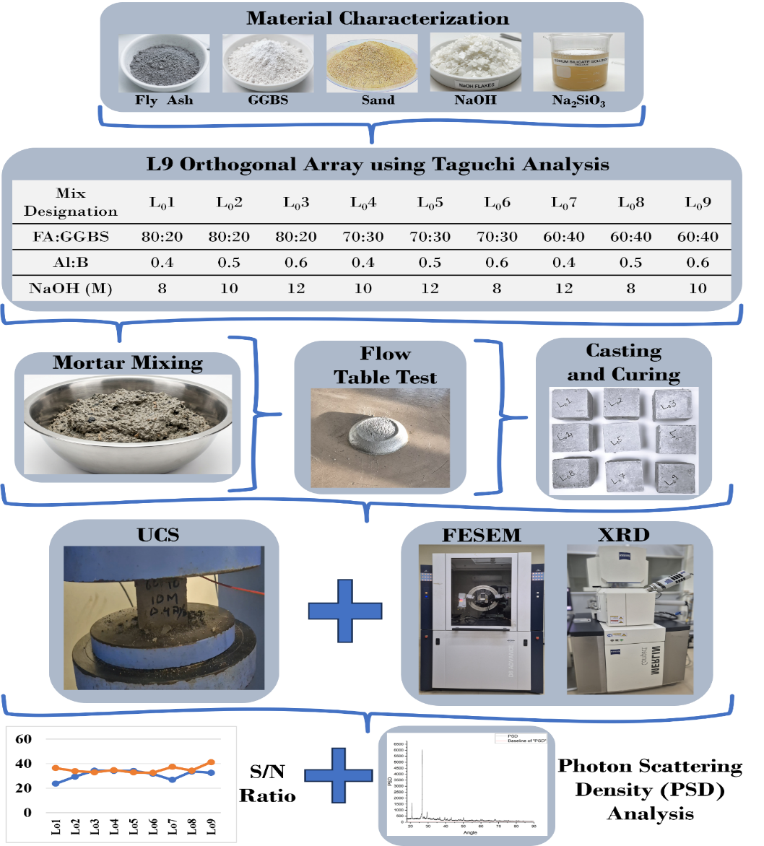
Fig. 1 Methodology for Alkali-Activated Mortar

Table 5: L9 Orthogonal Array
Experiment No. | Fly Ash: GGBS Ratio | Al: B Ratio | NaOH Molarity (M)
L_{o}1 | 80:20 | 0.4 | 8
L_{o}2 | 80:20 | 0.5 | 10
L_{o}3 | 80:20 | 0.6 | 12
L_{o}4 | 70:30 | 0.4 | 10
L_{o}5 | 70:30 | 0.5 | 12
L_{o}6 | 70:30 | 0.6 | 8
L_{o}7 | 60:40 | 0.4 | 12
L_{o}8 | 60:40 | 0.5 | 8
L_{o}9 | 60:40 | 0.6 | 10

- Signal-to-Noise Ratio (S/N ratio)
Taguchi analysis generally relies on signal-to-noise ratios to assess the robustness of the process relative to variability (noise). Different S/N ratio formulations are present, from which the adopted desired quality characteristic includes:
Larger-is-better: for maximising compressive strength or durability.
For example, for compressive strength, where higher is better, the larger-is-better S/N ratio is adopted and calculated using Equation 3.
$$\frac{S}{N}= -10\log\left[\frac{1}{n}\sum_{i=1}^{n}{\frac{1}{y_{i}^{2}}}\right]$$ | (1)
Where “y_{i}” is the measured response for the i^{th} trial and “n” is the number of repetitions.
In this study, a larger-is-better formulation was adopted for optimising ultrasonic pulse velocity, compressive strength, and flowability of the AAB mortar
For each row of the L9 array, AAB mortar mixtures are prepared with the corresponding fly ash-to-GGBS ratio, alkali-to-binder (Al/B) ratio, and NaOH molarity. All three factors contribute to the formation of the L9 Orthogonal array in Taguchi analysis, thus defining the experimental process for casting mortar specimens.
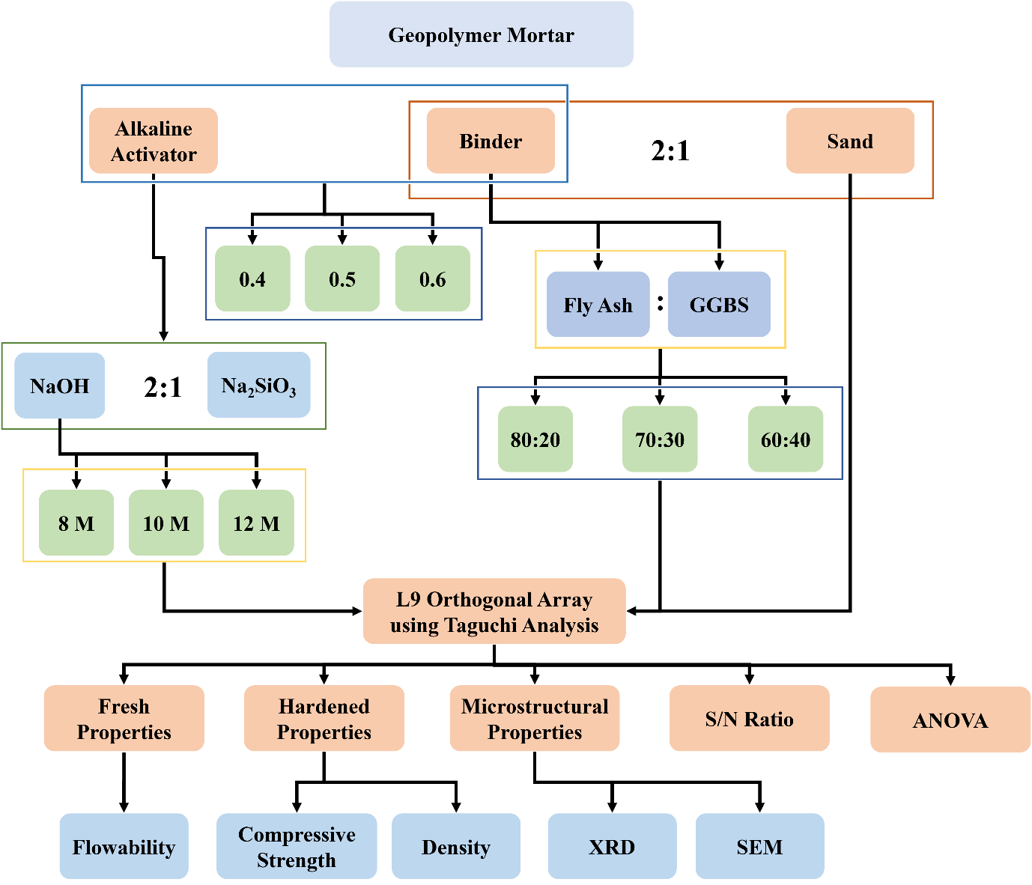
Fig. 2 Experimental Design
- Analysis of Variance (ANOVA)
ANOVA was conducted to quantify the percentage contributions of different factors to the mortar's characteristics. The sensitivity of a particular characteristic to changes in the factor can be quantified using the percentage contribution, calculated using Equation 4.
$$Percentage contribution=\left[\frac{Sum Square due to a particular factor}{Total corrected sum of squares}\right]*100$$ | (2)

Mix Design of AAB Mortar
The proportions of various constituent materials in the AAB mortar are shown in Table 6. In the mortar preparation, the sand-to-binder ratio was set at 2.0, which was constant across all combinations (Balahariharan et al., 2024; Zailani et al., 2024). This constant value was adopted after a thorough review of previous studies, which found that a sand-to-binder ratio of 2 yielded optimal results compared to other ratios.
For the experimental process, fly ash and GGBS were measured and kept aside. The NaOH solution was prepared by mixing 320 g of NaOH pellets with 0.5 litres of water, then diluting to 1 litre with water to obtain an 8 Molar solution. A similar step was followed to prepare the 10 M and 12 M NaOH solutions by mixing 400 grams and 480 grams of NaOH pellets, respectively. An industrial-grade Na₂SiO₃ solution was used in this study.
Binders and sand were then dry-mixed using the mortar mixer for 90 seconds. After that, the weighed alkaline solutions were added to the mixture, which was then mixed using the mixer machine for 180 seconds. The mixture was then used to conduct the flow table test to determine the flowability of the mortar samples. After this, the mortar was placed in the 70.6×70.6 mm moulds, with 25 tamps in 2 layers, and the weight of the mortar samples with the moulds was measured to evaluate the fresh density of the mortar specimens. The specimens were then demoulded and kept under ambient curing conditions (23-28°C).
Table 6: Proportions of AAB mortar (/ kg)
Experiment No. | Total Mass (kg) | Per Mix Mass (kg) | Fly ash (kg) | GGBS (kg) | NaOH (kg) | Na₂SiO₃ (kg) | Sand (kg)
L_{o}1 | 1 | 0.294 | 0.235 | 0.059 | 0.039 | 0.078 | 0.588
L_{o}2 | 1 | 0.286 | 0.229 | 0.057 | 0.048 | 0.095 | 0.571
L_{o}3 | 1 | 0.278 | 0.222 | 0.056 | 0.056 | 0.111 | 0.556
L_{o}4 | 1 | 0.294 | 0.206 | 0.088 | 0.039 | 0.078 | 0.588
L_{o}5 | 1 | 0.286 | 0.200 | 0.086 | 0.048 | 0.095 | 0.571
L_{o}6 | 1 | 0.278 | 0.194 | 0.083 | 0.056 | 0.111 | 0.556
L_{o}7 | 1 | 0.294 | 0.176 | 0.118 | 0.039 | 0.078 | 0.588
L_{o}8 | 1 | 0.286 | 0.171 | 0.114 | 0.048 | 0.095 | 0.571
L_{o}9 | 1 | 0.278 | 0.167 | 0.111 | 0.056 | 0.111 | 0.556

Test Methods
Different tests were conducted on the AAB mortar in its fresh and hardened states. The flowability of the mortar was assessed as per ASTM C1437(2001) where the fresh mortar was filled inside the flow cone placed on the flow table, and the table was dropped 15 times in 15 seconds with a drop height of 12.5 mm. This process was repeated for all mortar samples, with three trials per mix designation.
The mortar specimen’s compressive strength characteristic was assessed using IS: 4031 (Part 6), 2006, for which the 70.6 mm side cubes were tested after 28 days. For this, a servo-hydraulic machine was used to apply a compressive load at a rate of 0.23 MPa/sec, calculated by dividing the load sustained by the specimen’s cross-sectional area. According to IS 516, 1959, the compressive strength (CS) of each specimen must lie within 15% of the mean CS.
In addition to these, the microstructural properties were studied using X-ray diffraction (XRD) and scanning electron microscopy (SEM), further corroborating the analysis. The fine powder from the broken samples of the compressive strength testing, passing through a 90-micron sieve, was used, and the mixture was placed in the BRUKER D8 ADVANCE machine to determine the intensities of the elements corresponding to their respective phase angles. For the SEM analysis, small samples of size 2 cm × 2 cm were prepared using rubberised moulds, which were further surface polished to get a clean surface for the analysis using the ZEISS MERLIN COMPACT machine, which has a magnification range of 12 – 2.000.000x. Figure 2 shows the production and casting methodology for AAB mortar, along with the testing procedure.
Table 7: Testing Program
Test | Specimen | Standard | Age (days)
Workability Test | Fresh Mortar | ASTM C1437 | Immediately
Density | Fresh Mortar | ASTM C138 | Immediately
Ultrasonic Pulse Velocity | 70.6×70.6×70.6 (mm) | ASTM C597/ IS 13311 Part-1 | 28
Compressive Strength | 70.6×70.6×70.6 (mm) | IS 4031-Part 6 | 28
X-Ray Diffraction (XRD) | Powder | - | 28
Scanning Electron Microscope | Fractured Sample | - | 28

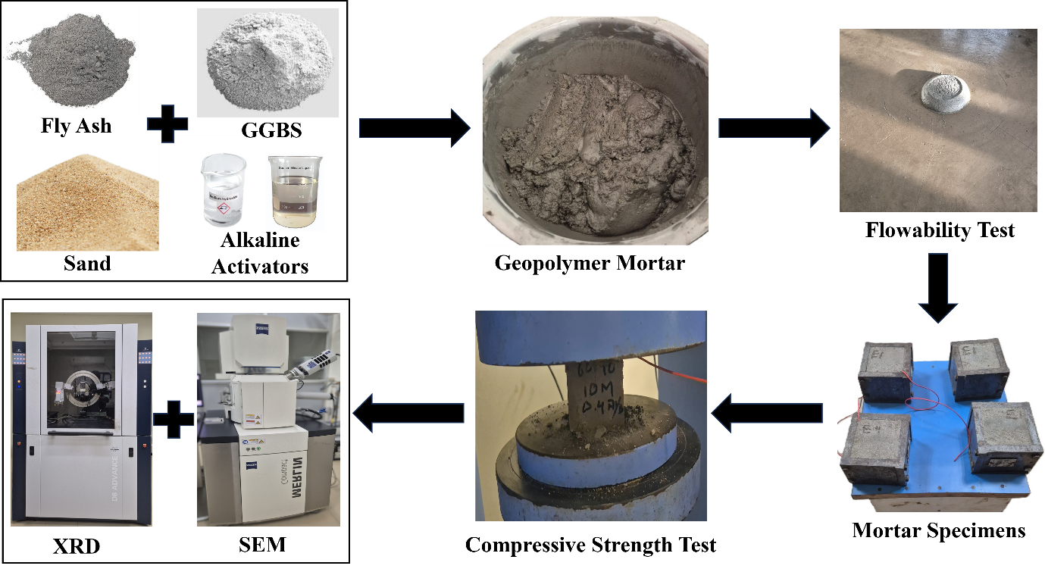
Fig. 3 Experimental Methodology and Testing Process

Results

Fresh Properties
    - Workability
Figure 3 shows the average flow table spread for the 9 different mortar combinations that are produced. The mix designations L₀4 and L₀8 showed the highest flowability spreads, at 154 mm and 148 mm, respectively, while L₀6 showed the lowest flowability. The overall flow table spread ranged from 110 mm to 160 mm across all samples. For cement mortar, as per IS 2250 (1981), the maximum consistency value is 130–150 mm for filling cavities. Also, as per ASTM C 270-07 (2007), which describes the standard specification of mortar for unit masonry, the laboratory mortar flow is specified as 110 mm±5%, measured using the flow table with 15 drops in 15 seconds (conforming to ASTM C1437 − 20), which is lower than the observed values found in the current experiment. One previous study recommended a minimum flow diameter of 150 ± 10 mm for good handling, mixing, and placement, with a 70:30 Class C FA: GGBS ratio and a Na₂SiO₃: NaOH ratio of 2 (Ardhira et al., 2024). Another study also suggested that values of 105–143 mm are commonly observed, with the best workability at a higher alkali activator/binder ratio of 0.75 and a 10 M NaOH concentration (Oyejobi et al., 2023).
Figure 3 presents the flow table spread values obtained for the nine geopolymer mortar mixtures. The measured flow diameters ranged from approximately 110 mm to 160 mm, indicating considerable variation in fresh-state behaviour resulting from differences in fly ash-to-GGBS ratio, activator-to-binder ratio, and NaOH molarity. Among the investigated mixtures, L₀4 and L₀8 exhibited the highest flowability, with spread diameters of 154 mm and 148 mm, respectively, whereas L₀6 demonstrated the lowest workability. The enhanced flowability observed in L₀4 and L₀8 can be attributed to improved lubrication from the alkaline activator solution and reduced internal friction between particles, thereby facilitating greater mobility of the fresh mortar. In contrast, the lower spread observed for L₀6 suggests increased mixture cohesion and a higher tendency for early reaction products to form during mixing, thereby restricting flow.
The results further indicate that workability was influenced by the combined interaction of precursor composition and alkaline activator characteristics. The incorporation of GGBS introduces finer particles with a larger specific surface area, which generally increases liquid demand; however, the simultaneous presence of an adequate activator content can compensate for this effect by improving particle dispersion. Moreover, the viscosity of the alkaline solution is strongly dependent on NaOH concentration and activator dosage, which directly affects the rheological behaviour of the geopolymer mortar. Therefore, the differences observed in flowability can be attributed to the combined effects of binder composition, alkali activator content, and alkali activator concentration rather than any individual mix parameter.
The measured flow values are consistent with the range commonly reported for alkali-activated binder mortars in the literature and generally satisfy the workability requirements necessary for mixing, handling, and casting operations. The ability to achieve adequate flowability without chemical admixtures demonstrates the suitability of the selected mix designs for practical geopolymer mortar applications.

Fig. 4 Flow Table spread for different Mix Designations
    - Density
Density depends on factors such as the fly ash: GGBS ratio, the alkaline activator-to-binder ratio, NaOH molarity, and the compaction factor. Figure 4 shows the variation in density for different mortar combinations. The L₀3 mix displayed the lowest density of 2198.33 kg/m³, while the L₀8 mixture depicted the highest density of 2298.33 kg/m³. Given our study's requirement for a structurally lightweight concrete mix, L₀4 and L₀5 can be adopted as mix designations with lower density, enabling the production of lightweight concrete without compromising strength. Hence, we adopted the smaller-is-better S/N ratio while analysing the density in the current study. Figure 4 displays the density variation graphically for the orthogonal array of mix designations. As of now, there are no codal provisions specifically prescribing a standard density for geopolymer mortars. But in the case of cement mortars, BIS, 1981 recommends laboratory values of nearly 2080 kg/m³, with a standard cement mortar mix of 1:6. Most studies and experimental works use an assumed or measured density, often referencing 2100–2200 kg/m³ as a practical average for design and reporting purposes. For example, a study conducted by Altawil & Olgun in 2025 assumed a standard density of 2200 kg/m³ for geopolymer mortar in their optimisation studies involving fly ash-silica fume blends with alkali activator to binder ratios of 0.30, 0.35, 0.40, and 0.45, which closely aligns with many experimentally reported values for similar systems. Further, in 2023, Thamer & Al-Jaberi reported a density of 2280 kg/m³ as the best result for metakaolin-based geopolymer mortar in their absorption and density tests, noting that density increases with increasing NaOH molarity from 6M to 15M, with the Na₂SiO₃/NaOH ratio constant at 1.5. Also, according to ASTM C 270-07, the density of conventional cement-lime mortar is 2000–2200 kg/m3, and for lightweight mortars, 1800 kg/m³. General reviews and mix design studies on geopolymer mortars commonly cite density values in the 2100–2300 kg/m³ range for normal-weight versions, with lightweight versions (using high fly ash content) falling below this (P. Zhang et al., 2018).
Figure 4 illustrates the density variation observed among the nine geopolymer mortar mixtures, which ranged from 2198.33 kg/m³ to 2298.33 kg/m³, indicating that all mixtures have relatively compact matrices within the typical density range reported for normal-weight alkali-activated mortars. Among the investigated compositions, L₀3 exhibited the lowest density, whereas L₀8 achieved the highest density. The observed variation in density is primarily attributed to differences in particle packing efficiency, the extent of gel formation, and the internal pore structure, resulting from changes in precursor composition and activator characteristics.

Fig. 5 Density Variation for Different Mix Designations
The higher density recorded for L₀8 suggests the formation of a more compact microstructure with reduced internal voids and improved packing of the reaction products. In contrast, the comparatively lower density of L₀3 may indicate a greater volume of entrapped pores or a less densely packed gel network. Since density is strongly influenced by the degree of pore refinement achieved during alkali-activation, the results suggest that the interaction between fly ash, GGBS, alkaline activator dosage, and NaOH molarity significantly affected the microstructural development of the mortar matrix.
  - Non-Destructive Test
    - Ultrasonic Pulse Velocity (UPV)
UPV is a non-destructive testing method that measures the speed of an ultrasonic pulse as it travels through a material, reflecting the material's internal condition and density and indicating the compactness and integrity of the matrix; higher velocities suggest fewer voids and defects. Figure 5 shows the variation in UPV for different mortar combinations. In the AAB mortar, the UPV values increased with increasing Al: B ratio. A similar trend was observed as GGBS content increased. The maximum UPV of 4287.589 m/s was observed with the L₀5 mix. Although the specifications most frequently refer to concrete, they are also commonly adapted for cement mortar, since the test matrix and pore structure remain similar (L. Li et al., 2025). Thus, the velocity classification as per IS 13311 (Part 1): 1992 and ASTM C597, 1989 suggests that a good-quality concrete must have a velocity classification greater than 3500 m/s.

Fig. 6 Ultrasonic pulse Velocity of mortar specimens
Ultrasonic Pulse Velocity (UPV) is widely used as a non-destructive indicator of matrix quality, internal structural integrity, and pore structure development in cementitious and alkali-activated materials. Figure 6 presents the variation in UPV for the experimental mortar mixtures. The results indicate that the pulse velocity generally increased with increasing activator-to-binder ratio and GGBS content, suggesting progressive improvement in matrix compactness and internal continuity. Among all mixtures, L₀5 exhibited the highest UPV value of 4287.589 m/s, indicating superior internal quality and a highly consolidated microstructure. According to IS 13311 (Part 1): 1992 and ASTM C597, materials exhibiting ultrasonic pulse velocities greater than 3500 m/s are generally classified as possessing good internal quality. All investigated mixtures met this criterion, indicating that the developed mortars had adequate structural integrity and relatively few internal defects. The highest velocity recorded for L₀5 approached the threshold for excellent-quality materials, further confirming the effectiveness of the selected mix parameters in promoting a dense, well-bonded alkali-activated matrix.
The observed increase in UPV can be attributed to the enhanced dissolution of aluminosilicate compounds and consequent formation of alkali-activated reaction products, which progressively filled internal voids and improved particle connectivity within the matrix. The presence of GGBS provided additional calcium ions, which promoted the formation of calcium aluminosilicate hydrate (C-A-S-H) type gels alongside sodium aluminosilicate hydrate (N-A-S-H) gels, resulting in a denser, more continuous microstructure. Consequently, ultrasonic wave propagation exhibited reduced scattering and attenuation, resulting in higher measured pulse velocities.
The UPV results give strong agreement with the previously discussed density measurements, as mixtures with improved matrix compactness generally exhibit higher pulse velocities. Since ultrasonic waves are highly sensitive to internal defects, pore connectivity, and microcracking, the elevated UPV values suggest reduced internal void content and improved homogeneity of the alkali-activated matrix. Furthermore, higher UPV values are often associated with enhanced mechanical performance because both properties are governed by the quality and continuity of the load-transfer network formed during alkali activation (M. Li et al., 2025). Therefore, the UPV results provide indirect evidence of effective gel formation and microstructural refinement, which are expected to contribute positively to the compressive strength behaviour discussed in the subsequent section.
  - Mechanical Properties
    - Compressive strength of Mortar
As reported in previous studies, compressive strength was lower at a lower Al: B ratio than at a higher Al: B ratio (Shilar et al., 2022; Ulloa et al., 2024). This is demonstrated by the experimental tests conducted in the current study. With the Al/ B ratio of 0.4, the compressive strength was always found to be lower than the other two cases of 0.5 and 0.6. The maximum and minimum compressive strengths were obtained for the L₀3 and L₀7 combinations, respectively. It is observed that compressive strength increases significantly with increasing Al/B and molarity, corroborating previous studies (Altawil & Olgun, 2025b; Thamer & Al-Jaberi, 2023). The 28-day compressive strength for 10 M NaOH, with both the Na₂SiO₃/NaOH ratio and the alkaline activator-to-binder ratio set at 2, was 20±2 MPa. Further, as the GGBS content increases, compressive strength increases, mainly due to the higher CaO content in GGBS, which creates an alkaline environment for alkali activation. Other studies show optimal compressive strengths around 17-60 MPa depending on curing conditions, molarity (8M-16M), and FA: GGBS ratios, with higher GGBS proportions enhancing strength (H. Zhang et al., 2025). Another study using an FA: GGBS ratio of 70:30 and a constant Na₂SiO₃/NaOH ratio of 2 under ambient curing achieved a compressive strength of 40.64 MPa at 28 days (Ardhira et al., 2024).

Fig. 7 Compressive Strength values of mortar specimens
Figure 5 shows the 28-day compressive strength results obtained for the geopolymer mortar mixtures. A clear influence of activator-to-binder ratio, NaOH molarity, and precursor composition on strength development was observed. Among the investigated mixtures, L₀3 achieved the highest compressive strength, whereas L₀7 exhibited the lowest value. The results indicate that increasing the activator-to-binder ratio from 0.4 to 0.6 generally enhances compressive strength, suggesting that greater availability of alkaline species promotes the dissolution of aluminosilicate precursors and accelerates the alkali-activation process. Similarly, a higher NaOH molarity improved reaction kinetics by increasing the concentration of hydroxyl ions available for precursor dissolution.
The superior performance of L₀3 can be attributed to the formation of a dense, well-connected alkali-activated matrix, driven by effective dissolution, polycondensation, and gel formation. The combination of sufficient alkaline activator availability and an appropriate fly ash-to-GGBS ratio likely promoted the simultaneous formation of N-A-S-H and C-A-S-H reaction products. These gels collectively improved particle bonding, reduced pore connectivity, and enhanced load-transfer efficiency within the matrix. In contrast, the lower strength observed in L₀7 suggests incomplete reaction and a less continuous gel network, resulting in reduced matrix integrity.
The compressive strength results are consistent with the density and UPV measurements presented in the previous sections. Mixtures exhibiting improved matrix compactness generally demonstrated higher pulse velocities and greater compressive strength, indicating that pore refinement and microstructural densification played a significant role in strength development. During alkali activation, the progressive formation of reaction products fills internal voids and strengthens interparticle bonds, thereby increasing resistance to compressive loading.
Although higher alkaline activator content generally enhanced strength, the results indicate that strength development was not governed by any single parameter. For example, mixtures with identical NaOH molarity exhibited significantly different compressive strengths, demonstrating that the interaction between the precursor composition and the activator dosage was equally important. This observation suggests that the extent of alkali-activation, rather than the absolute concentration of the alkaline solution, controlled the final mechanical performance. Subsequent XRD, PSD, SEM, and EDS analyses are therefore used to examine the evolution of crystalline phases, reaction products, and microstructural features that underlie the observed strength behaviour in the following sections.
  - Microstructural Properties
    - X-Ray Diffraction (XRD)
X-ray diffraction (XRD) analysis of the mortar mixtures complements the properties by revealing the crystalline phases and the chemical composition responsible for the geopolymerization process, and showing the formation of aluminosilicate networks that enhance mechanical strength. Together, UPV, compressive strength, and XRD provide a comprehensive understanding of how the chemical composition influences the microstructure and mechanical performance of geopolymer mortar, demonstrating that higher alkali activator concentrations and optimised ratios lead to denser matrices, increased crystalline bonding, and superior strength (Pourabbas Bilondi et al., 2025).
The peak intensity of mix designation L₀3 is 1451 at a phase angle of 27.54°, indicating that it corresponds to the phase mineral silicon dioxide (Quartz), a major strength-enhancing factor. Between phase angles 27-29°, the N-A-S-H phase was observed, which plays an important role in intermolecular bonding, thereby increasing density and strength. Similarly, for mix L₀4 at a phase angle of 26.66, the maximum intensity of 3228 was for mineral silicon dioxide (Quartz). Between the phase angles of 20° and 35°, the broad hump characteristic of the N-A-S-H gel (amorphous sodium aluminosilicate hydrate) was found.
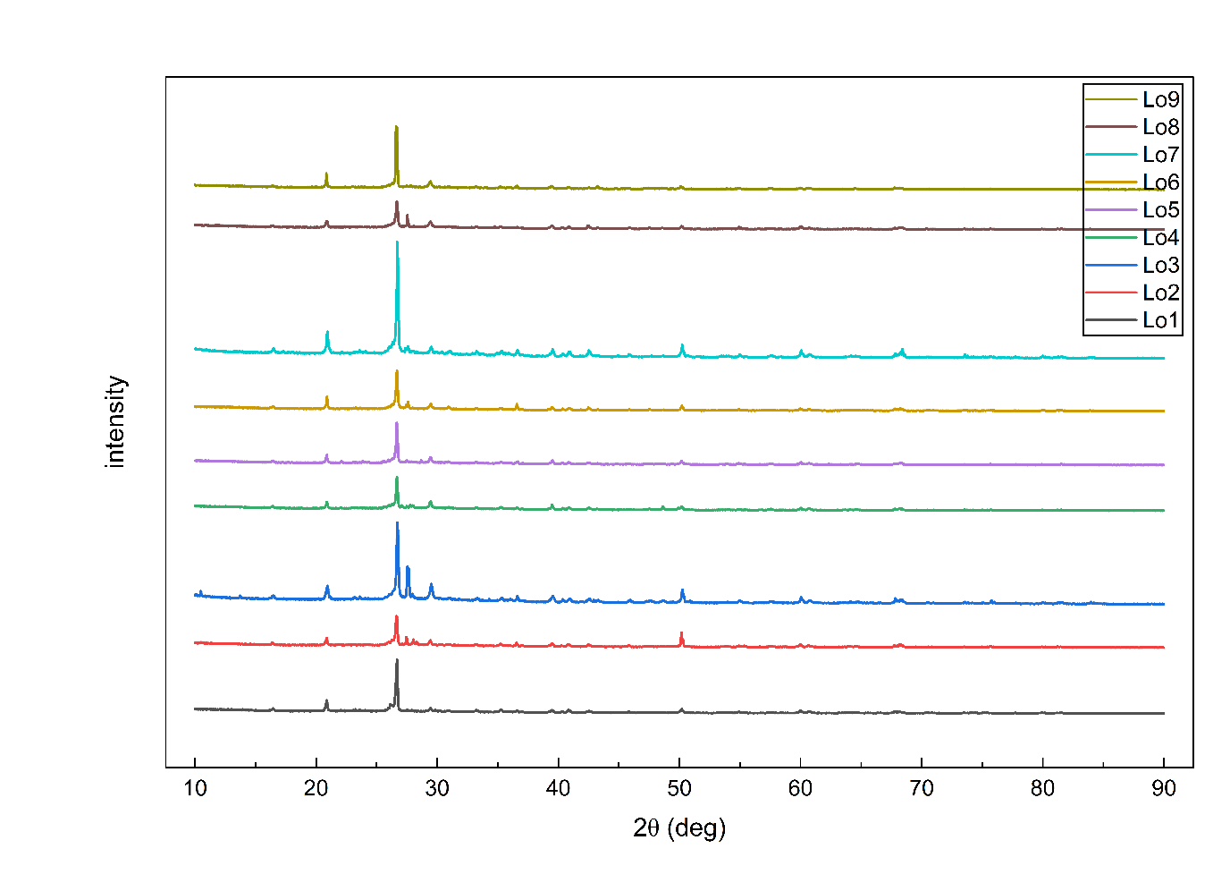
Fig. 8 X-Ray Diffraction graphs of the mortar specimens
Where very high, sharp peaks near 27-29° 2θ indicate quartz, the wide, diffused (background) hump underlying this region signals the presence of amorphous N-A-S-H gel (M. Li et al., 2025). The presence of this broad hump is a key indicator of successful geopolymerization and the formation of the target aluminosilicate gel. The broad amorphous hump between approximately 20° and 35° 2θ is commonly associated with geopolymer gel formation and is attributed to N-A-S-H/C-A-S-H reaction products (L. Li et al., 2025).
X-ray diffraction (XRD) analysis was performed to investigate the phase accumulation and reaction products formed during alkali activation. X-ray diffraction analysis was performed using a BRUKER D8 ADVANCE diffractometer equipped with Cu-Kα radiation (λ = 1.5406 Å), operated at 40 kV and 40 mA. Finely ground powder passing a 90 µm sieve was scanned over a 2θ range of 5°–80° using a step size of 0.02° and a scanning rate of 2° min⁻¹. Phase identification was performed by comparing the diffraction patterns obtained with those in the International Centre for Diffraction Data (ICDD) database. The diffraction patterns revealed the coexistence of residual precursor phases, primarily quartz and mullite, together with a broad amorphous hump characteristic of gel formation. The presence and evolution of these phases provide valuable information on the extent of precursor dissolution, the progress of the reaction, and the development of the hardened alkali-activated matrix.
The XRD results should be interpreted in conjunction with density, UPVs, compressive strength, SEM, and EDS analyses, as the mechanical performance of alkali-activated mortars is governed not only by the quantity of crystalline phases present but also by the formation and connectivity of amorphous reaction products. Consequently, XRD is an important tool for linking phase evolution to the observed engineering properties of the mortar mixtures investigated.
The diffraction pattern of L₀3 (Figure 7) exhibited a dominant quartz reflection near 26.6° 2θ together with several secondary quartz-related peaks at higher diffraction angles. The persistence of quartz peaks indicates the presence of residual crystalline silica originating from the precursor materials. However, the diffraction pattern also displayed a broad amorphous hump extending approximately from 20° to 35° 2θ, which is widely recognised as evidence of geopolymer gel formation. The coexistence of residual crystalline phases and a substantial amorphous component suggests that geopolymerization proceeded extensively while retaining a stable crystalline framework. This phase assemblage is consistent with the superior compressive strength and high UPV values observed in L₀3, indicating the development of a dense and mechanically efficient matrix. Similar behaviour was observed for L₀4 (Figure 8), where the strongest diffraction peak corresponded to quartz at approximately 26.6° 2θ. In addition to the crystalline quartz reflections, a broad amorphous hump was observed between 20° and 35° 2θ, indicating the formation of geopolymeric reaction products. The simultaneous presence of residual crystalline phases and amorphous gels suggests partial dissolution of the precursor materials followed by extensive polycondensation. Although L₀4 exhibited a phase assemblage comparable to that of L₀3, differences in reaction extent, gel connectivity, and pore refinement are likely responsible for the variations observed in mechanical performance.
Collectively, the XRD and PSD results demonstrate that alkali-activation involves the transformation of reactive aluminosilicate species into predominantly amorphous binding gels while retaining a proportion of unreacted crystalline phases. The crystalline phases contribute to particle packing and dimensional stability, whereas the amorphous reaction products primarily contribute to strength development and matrix densification. Consequently, the observed engineering properties of the geopolymer mortars are governed by the interaction between residual crystalline constituents and newly formed geopolymeric gels rather than by either component acting independently.
  - Photon Scattering Density (PSD)
Photon Scattering Density (PSD) is defined as the cumulative X-ray scattering response associated with a selected crystalline phase under identical diffraction conditions. The parameter employed in this study is taken as a comparative scattering index rather than a physical density. X-ray diffraction (XRD) is widely employed to identify crystalline phases in alkali-activated materials; however, conventional interpretation is generally limited to qualitative identification of mineral phases and comparison of dominant diffraction peaks.
In the present study, a PSD approach was adopted as a semi-quantitative comparative framework to evaluate the relative diffraction response of selected crystalline phases. The methodology enables systematic comparison of phase persistence among different alkali-activated mortar mixtures while maintaining identical XRD acquisition conditions.
Following phase identification using the ICDD database, characteristic diffraction peaks corresponding to Quartz, Mullite, Calcite, Hematite and other identified crystalline phases were selected. The same reflections were consistently used for all mortar mixtures to ensure direct comparison. Peak intensities were extracted directly from the diffraction patterns using OriginPro software, and the cumulative intensity of the selected reflections was defined as the Peak Photon Scattering Density (Peak PSD).
    - Peak intensity PSD Values
The Peak Intensity PSD approach was used to quantify the relative contributions of the major crystalline phases identified in the XRD patterns. Since peak height alone does not completely represent the diffraction response of a crystalline phase, the integrated diffraction intensity was also evaluated. For each selected characteristic reflection, the area under the intensity–2θ profile was determined by numerical integration in OriginPro. The Integrated Photon Scattering Density for the crystalline phases were calculated as per Equation 3.
$${PSD}_{peak}= \sum_{i=1}^{n}{I_{i}}$$ | (3)
Where, I_{i} = measured intensity of the i^{th} characteristic diffraction peak,
n = number of characteristic peaks selected for that phase,
whereas the integrated photon scattering density for the amorphous reaction gel of N-A-S-H and C-A-S-H gel is calculated as per Equations 4 and 5, respectively. The maximum of the hump for N-A-S-H is usually around 27°-31°, whereas the broad maximum for C-A-S-H gel is near 29°-36°.
$${PSD}_{NASH}= \int_{22°}^{38°}{I\left(2θ\right)d\left(2θ\right)}$$ | (4)
$${PSD}_{CASH}= \int_{28°}^{36°}{I\left(2θ\right)d\left(2θ\right)}$$ | (5)
The calculated Peak Intensity PSD values for quartz, mullite, and calcite are presented in Table 8. Since the method is based on measured peak maxima, it reflects the relative dominance of crystalline phases within the matrix and provides a rapid assessment of phase evolution resulting from changes in precursor composition and activator characteristics. Consequently, Peak Intensity PSD is a useful tool for comparing the development of crystalline phases across multiple geopolymer mixtures.
Table 8 Peak PSD Values of identified mineral and reaction product phases
PSD Dataset | L₀1 | L₀2 | L₀3 | L₀4 | L₀5 | L₀6 | L₀7 | L₀8 | L₀9
Quartz PSD | 8773 | 6853 | 13092 | 6104 | 6597 | 7587 | 18923 | 5571 | 7493
Mullite PSD | 2152 | 2116 | 3482 | 1974 | 1838 | 1903 | 4075 | 1817 | 1854
Calcite PSD | 1101 | 1426 | 2811 | 1682 | 1478 | 1373 | 2148 | 1548 | 1760
N-A-S-H
C-A-S-H
Cumulative PSD | 12026 | 10395 | 19385 | 9760 | 9913 | 10863 | 25146 | 8936 | 11107

The results in Table 8 reveal substantial variation in the contributions of crystalline phases among the investigated mixtures. L₀7 exhibited the highest quartz PSD (18,923) and the highest overall PSD value (25,146), indicating the strongest contribution from residual crystalline phases. In contrast, L₀8 recorded the lowest total PSD (8,936), suggesting a comparatively lower contribution from the crystalline phase. Interestingly, the highest total PSD did not correspond to the highest compressive strength. While L₀7 exhibited the greatest cumulative crystalline scattering response, it simultaneously produced the lowest compressive strength among the investigated mixtures. Conversely, L₀3 achieved the highest compressive strength despite exhibiting a lower total PSD than L₀7.
From an alkali-activation perspective, elevated crystalline PSD values generally indicate the presence of crystalline phases within the hardened matrix. Depending on the mineral phase involved, this may reflect incomplete precursor dissolution and/or inherent stability of relatively unreactive constituents. While these phases contribute to particle packing and scattering intensity, they do not necessarily play a significant role in load-bearing mechanisms. Strength development is primarily governed by the formation of a continuous reaction-product network dominated by amorphous or poorly crystalline N-A-S-H and C-A-S-H gels. Consequently, mixtures exhibiting relatively high crystalline PSD do not necessarily develop higher compressive strength if the extent of gel formation and matrix densification remains limited. This phenomenon explains the apparent discrepancy between the PSD and compressive strength results and highlights the importance of integrating PSD analysis with SEM-EDS and XRD evaluations of the amorphous hump.
This observation suggests that mechanical performance is not solely determined by the quantity of crystalline phases present in the matrix. Instead, the results indicate that the formation and continuity of amorphous reaction products play a more dominant role in strength development. Therefore, Peak Intensity PSD should be interpreted primarily as an indicator of the residual crystalline-phase contribution rather than a direct predictor of mechanical performance. Thus, to address the limitations of peak-based analysis, an Integrated Area PSD approach was also employed.
  - Integrated Area PSD values
Unlike Peak Intensity PSD, the Integrated Area PSD accounts for the complete diffraction profile of each characteristic reflection and therefore provides a more representative measure of the overall scattering contribution of a phase. The method was implemented by integrating the background-corrected area beneath the selected diffraction peaks, as expressed in Equation 4. Because the entire peak profile is considered, the Integrated Area PSD is less sensitive to random fluctuations in peak height and more accurately reflects the cumulative contribution of crystalline phases within the alkali-activated matrix.
$${PSD}_{phase}= \sum{\int_{peak}{\left(I-I_{background}\right) d(2θ)}}$$ | (4)
Consequently, Integrated Area PSD provides a valuable framework for comparing phase evolution, assessing reaction progress, and evaluating the relative abundance of crystalline constituents across different mixtures. The calculated values for quartz, mullite, calcite, and total PSD are presented in Table 9.
The results demonstrate substantial variation in the contributions of crystalline phases among the investigated mixtures. L₀7 exhibited the highest integrated quartz PSD (2333) and the highest total PSD index (2820), indicating the strongest contribution from residual crystalline phases. In contrast, L₀8 recorded the lowest total PSD index (995), suggesting a comparatively lower abundance of the crystalline phase. Similarly, L₀3 displayed the highest calcite PSD (537.1), indicating a stronger contribution from calcium-bearing crystalline phases.
A particularly important observation is that the highest integrated PSD values did not correspond to the highest compressive strengths. Although L₀7 exhibited the largest cumulative crystalline scattering contribution, it simultaneously produced the lowest compressive strength among the investigated mixtures. Conversely, L₀3 achieved the highest compressive strength despite exhibiting a lower total PSD than L₀7. These findings indicate that the abundance of the crystalline phase alone cannot explain the mechanical behaviour of geopolymer mortars.
Table 9: Integrated area PSD values
PSD Dataset | L₀1 | L₀2 | L₀3 | L₀4 | L₀5 | L₀6 | L₀7 | L₀8 | L₀9
Quartz PSD | 1040 | 897.5 | 1799 | 682.9 | 863.1 | 969.1 | 2333 | 710 | 1139
Mullite PSD | 125.9 | 117 | 122.7 | 97.6 | 102.9 | 86.4 | 183.8 | 72.8 | 197.3
Calcite PSD | 117.9 | 193.4 | 537.1 | 243.4 | 235.8 | 203.2 | 303.2 | 212 | 266.5
N-A-S-H
C-A-S-H
Total PSD Index | 1284 | 1208 | 2459 | 1024 | 1202 | 1259 | 2820 | 995 | 1603
From a geopolymerization perspective, Integrated Area PSD primarily quantifies the contribution of residual crystalline phases that remain after alkali activation. While these phases contribute to structural dimensional stability and particle packing, they are not the principal load-bearing components of the hardened matrix. Instead, compressive strength development is largely governed by the formation of amorphous reaction products, particularly N-A-S-H and C-A-S-H gels, which are only partially represented within conventional crystalline phase analysis. Therefore, the inverse relationship observed between total PSD and compressive strength for certain mixtures suggests that extensive retention of crystalline phases may indicate incomplete precursor dissolution and lower reaction efficiency (Su et al., 2026). This interpretation is consistent with the hypothesis that strength development depends more strongly on gel formation than on residual crystalline content. Thus, the mechanical performance of FA-GGBS alkali-activated mortar is governed by the balance between residual crystalline persistence and amorphous gel development rather than by crystalline abundance alone.
    - Scanning Electron Microscope
SEM-EDS analysis of L₀1 revealed a heterogeneous microstructure characterised by partially reacted fly ash particles embedded within an alkali-activated reaction matrix. Figure 8 clearly shows that large spherical particles retained their original morphology, indicating incomplete dissolution of the aluminosilicate precursor. EDS analysis of these regions showed elevated silicon content (up to 25.85 wt.%) and relatively low calcium concentrations, confirming the presence of residual silica-rich precursor phases. Overlayed surface deposits and reaction rims were observed on several fly ash particles. EDS analysis revealed elevated Na, Si, and Al concentrations, with a comparatively low Ca content (2.03 wt.%), indicating that these features are associated with geopolymeric reaction products. The morphology suggests progressive dissolution of the fly ash surface followed by precipitation of N-A-S-H-rich gel phases. The coexistence of residual precursor particles and geopolymeric reaction products suggests that dissolution and polycondensation were incomplete under the selected activation conditions. These observations are consistent with the XRD and PSD analyses, which indicated significant contributions from quartz and mullite, and explain the comparatively lower density, UPV, and compressive strength obtained for L₀1.
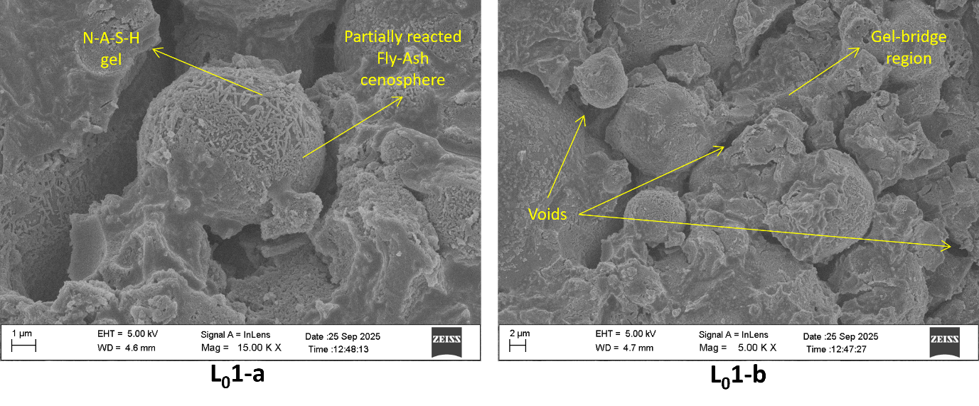
Fig. 9 SEM-EDS of Mix L₀1
SEM-EDS analysis of L₀2 revealed a more developed alkali-activated microstructure compared with L₀1. Several fly ash particles retained their spherical morphology but exhibited extensive surface etching and reaction rims, indicating greater precursor dissolution than in L₀1 (Figure 9 – L₀2-a). The surrounding matrix appeared denser and more continuous, with improved interparticle bonding and reduced pore connectivity, as shown in Figure 9 - L₀2-b. EDS analysis demonstrated elevated concentrations of Si, Al, and Na in the reaction products, confirming extensive dissolution of the precursors and the formation of aluminosilicate geopolymeric gels. In addition, an increase in Ca concentration of 2.53 wt. % suggests partial incorporation of GGBS-derived calcium into the reaction phase, potentially contributing to the formation of hybrid N-A-S-H/C-A-S-H type binding phases. Still, visible voids in the matrix indicate that the L₀2 mixture is not fully densified. These observations indicate a higher degree of alkali activation than observed for L₀1 and are consistent with the expected improvement in mechanical performance from increased alkali activator dosage.
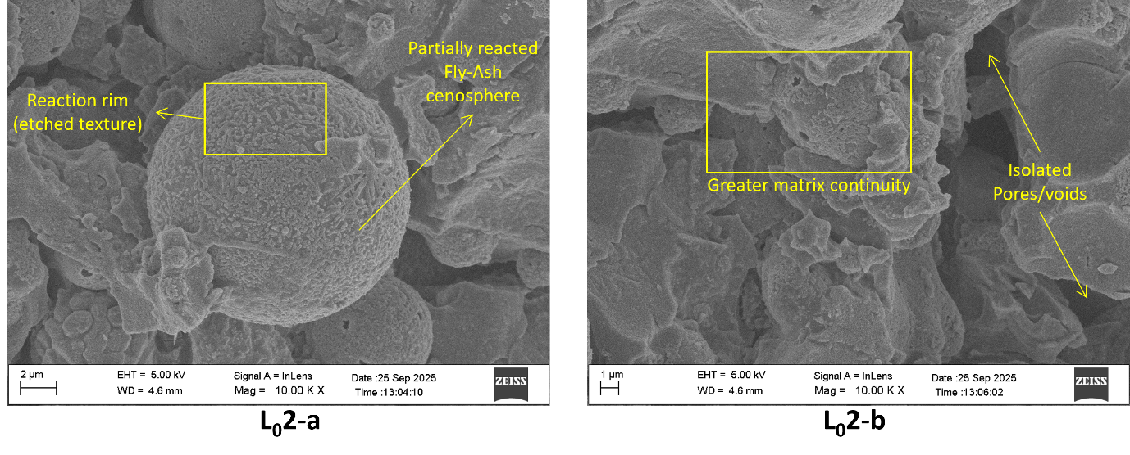
Fig. 10 SEM-EDS of Mix L₀2
SEM-EDS analysis of L₀3 revealed the most compact and chemically developed microstructure among the investigated mixtures. Figure 10 shows extensive surface dissolution of fly ash particles, together with well-developed reaction rims and dense interparticle gel regions. EDS analysis showed elevated concentrations of Si, Al, and Na in several regions, confirming the formation of N-A-S-H reaction products, with an average Si+Al wt. % of 28.36. Furthermore, regions containing significant Ca concentrations (up to 7.10 wt.%) together with Si and Al indicate the participation of GGBS in the reaction process and the formation of calcium-containing geopolymeric gels. The coexistence of Na and Ca-rich reaction products suggests the development of a hybrid N-A-S-H/C-A-S-H binding network, along with reduced pore connectivity, enhances matrix densification and mechanical performance. These observations are consistent with the high compressive strength, elevated UPV values, and strong geopolymerization signatures identified through XRD and PSD analyses.
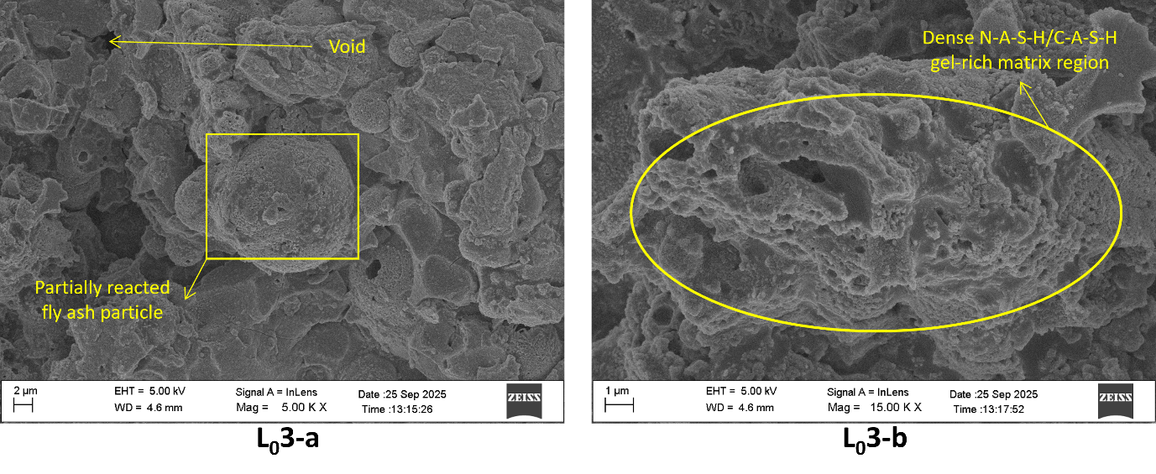
Fig. 11 SEM-EDS of Mix L₀3
SEM-EDS analysis of L₀4 revealed a dense and chemically homogeneous microstructure characterised by partially reacted fly ash particles embedded within a continuous geopolymeric matrix (Figure 11). In comparison to L₀3 extensive reaction rims and strong particle dissolution indicate substantial precursor participation in the alkali-activation process. EDS analysis demonstrated elevated concentrations of Na, Si, Al, and Ca throughout the matrix, confirming the formation of a hybrid geopolymeric binder incorporating both aluminosilicate (22.70% wt.) and calcium-bearing reaction products (3.55% wt.). Compared with L₀1 and L₀2, the reaction products in L₀4 exhibited more uniform gel chemistry, stronger calcium participation, greater chemical uniformity and a more continuous matrix, indicating improved alkali-activation. These observations are consistent with the comparatively lower residual crystalline PSD values obtained from XRD analysis and explain the high compressive strength and UPV values recorded for this mixture as well.
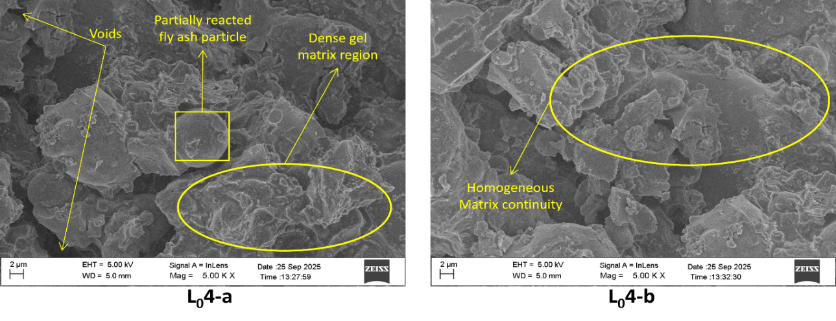
Fig. 12 SEM-EDS of Mix L₀4
SEM-EDS analysis of L₀5 revealed a highly continuous and chemically homogeneous microstructure characterised by extensive gel formation and a substantial reduction in recognisable precursor particles. Unlike the lower-activated mixtures, the matrix in L₀5-a was dominated by continuous reaction products with minimal pore connectivity and strong interparticle bonding. EDS analyses conducted at six different locations exhibited remarkably similar elemental compositions, indicating uniform alkali-activation throughout the microstructure. The reaction products were enriched in Si, Al, and Na, while a moderate Ca concentration of 1.99% by weight suggests limited but consistent participation of GGBS-derived calcium in the binding network, as shown in Figure L₀5-b. The high degree of matrix continuity and chemical uniformity observed in L₀5 indicate advanced alkali activation and provide a microstructural basis for its favourable mechanical performance and durability.
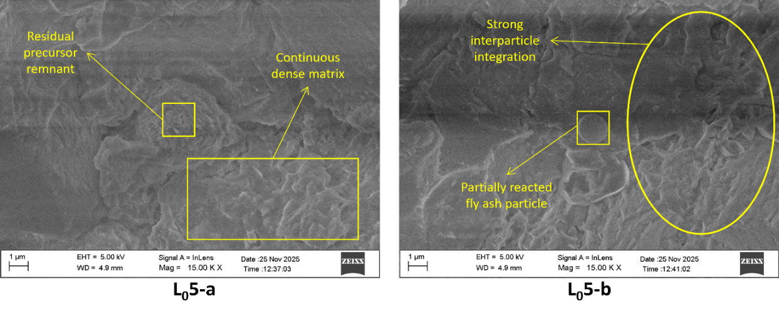
Fig. 13 SEM-EDS of Mix L₀5
SEM-EDS analysis of L₀6 revealed a heterogeneous microstructure characterised by partially reacted fly ash particles, angular precursor remnants, and discontinuous geopolymeric reaction products. The micrographs showed numerous spherical and plate-like particles, indicating incomplete precursor dissolution compared with the more extensively reacted L₀3–L₀5 mixtures. EDS analysis yielded average Si and Al concentrations of 19.46 wt.% and 6.49 wt.%, respectively, confirming the availability of reactive aluminosilicate species. However, the average Na concentration remained comparatively low (3.41 wt.%), suggesting reduced alkali incorporation into the reaction products. Although calcium participation was evident (average Ca = 2.93 wt.%), the reaction matrix exhibited lower continuity and greater precursor retention than the higher-performing mixtures. These observations indicate that lower Na incorporation due to lower molarity reduced dissolution efficiency and hindered the formation of a dense geopolymeric binder network.
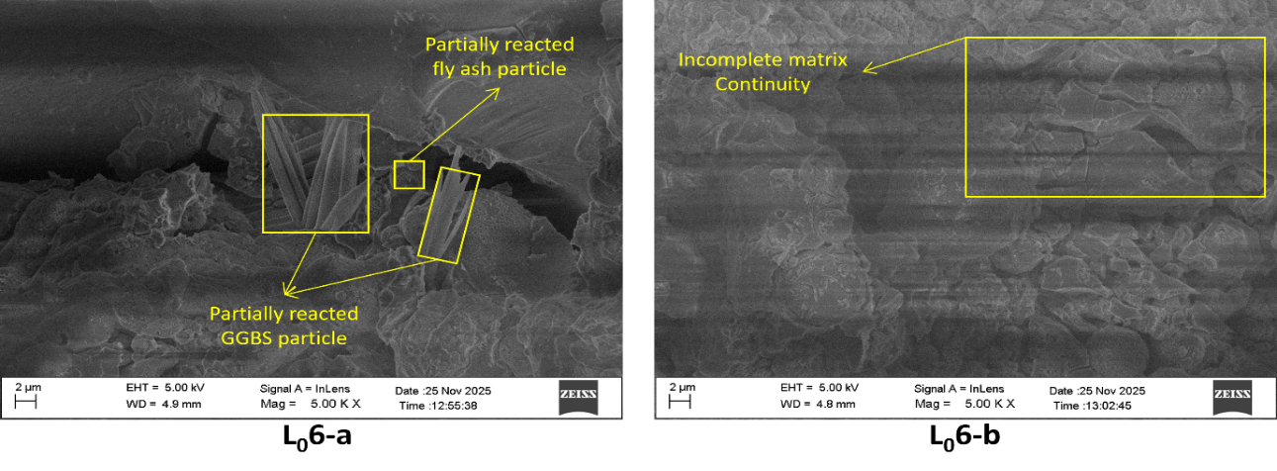
Fig. 14 SEM-EDS of Mix L₀6
SEM analysis of L₀7 revealed a microstructure dominated by elongated acicular crystalline products together with residual precursor particles and discontinuous reaction regions. Unlike the dense gel matrices observed in L₀3–L₀5, the L₀7 microstructure was characterised by limited matrix continuity. EDS analyses showed consistently high silicon contents (21.51–23.52 wt.%) but comparatively low aluminium concentrations (2.93–6.53 wt.%), resulting in elevated Si/Al ratios and suggesting incomplete development of a well-connected aluminosilicate binding network. The average Na concentration remained low (2.99 wt.%), indicating limited alkali incorporation despite the use of 12 M NaOH. Although L₀7 exhibited the highest PSD values among all mixtures, the SEM observations indicate that the increased crystalline content was associated with discrete crystal growth rather than the formation of a continuous alkali-activated gel, since strength is not governed by total aluminosilicate quantity alone but also depends on how effectively the precursors form a continuous binding network. Also, the total PSD of mixture L₀7 was the highest at 25146, but the compressive strength was the lowest, suggesting that PSD may reflect crystalline-phase abundance rather than stronger alkali-activated gel quality.
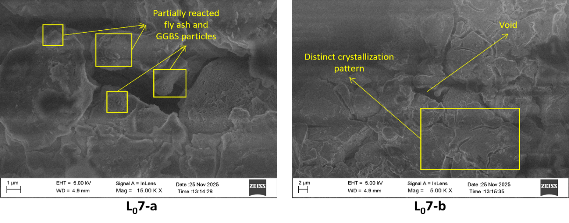
Fig. 15 SEM-EDS of Mix L07
L₀8 exhibited one of the most complex reaction environments among all investigated mixtures. EDS analysis revealed the coexistence of highly polymerised aluminosilicate gel regions (Si/Al ≈ 1.41), extremely sodium-rich precipitated phases (Na = 27–31 wt.%), and localised calcium-rich reaction products (Ca = 12.72 wt.%) as shown in Figure 15-L₀8-b. These observations indicate that precursor dissolution was extensive; however, the dissolved species did not precipitate into a chemically uniform binding network. Instead, multiple competing reaction pathways appear to have developed simultaneously, resulting in heterogeneous phase distribution throughout the matrix. While the low PSD values suggest effective dissolution of the crystalline precursor phases, the EDS results indicate that some of the dissolved alkalis accumulated in localised regions rather than being fully incorporated into the alkali-activated matrix framework (Figure 15-L₀8-a). Consequently, L₀8 represents a system in which extensive reaction occurred, but neither reaction efficiency nor chemical homogeneity was maximised (reason-temperature-winter season). This resulted in efflorescence due to the high concentration of Na⁺ ions. This distinction is critical because it doesn’t prove it to be a failed mortar specimen, but rather proves it to be a highly reactive system where the reaction products form multiple chemically distinct domains instead of one single, continuous, homogeneous gel network.
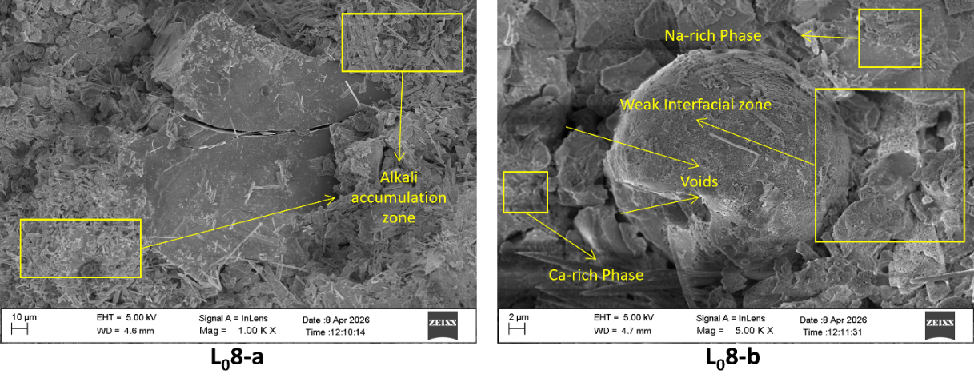
Fig. 16 SEM-EDS of Mix L₀8
SEM-EDS analysis of L₀9 revealed a relatively homogeneous and well-developed geopolymeric matrix characterised by balanced aluminosilicate chemistry and moderate calcium participation. The matrix regions exhibited Si concentrations ranging from 17.75 to 22.83 wt.% and Al concentrations ranging from 3.83 to 9.21 wt.%, resulting in Si/Al ratios consistent with mature geopolymer gel formation. Unlike L₀8, no sodium-rich segregated phases were identified, and unlike L₀7, no extensive needle-shaped crystallisation was observed. Residual fly ash-derived particles remained, as seen in Figure 16 - L₀9-a, present but largely encapsulated within the surrounding reaction matrix. The average aluminosilicate content (Si+Al) reached approximately 27.34 wt.%, among the highest values observed, indicating efficient precursor utilisation and extensive geopolymerization. These observations suggest that L₀9 achieved a balanced reaction environment, capable of producing a relatively continuous, chemically uniform load-bearing matrix with minimal phase segregation and moderate calcium participation.
Table 10 Average SEM-EDS Chemistry and Gel Characteristics of All Mixtures
Mix | Si+Al (wt.%) | Si/Al (wt.%) | Na/Al (wt.%) | Ca/Si (wt.%) | Dominant Interpretation
L₀1 | 23.58 | 3.37 | 1.81 | 0.11 | Early N-A-S-H formation; incomplete reaction
L₀2 | 22.75 | 2.62 | 1.12 | 0.15 | Improved geopolymerization
L₀3 | 28.36 | 2.31 | 0.69 | 0.20 | Hybrid N-A-S-H/C-(A)-S-H network
L₀4 | 22.70 | 2.51 | 1.48 | 0.22 | Uniform hybrid geopolymer matrix
L₀5 | 23.97 | 3.12 | 1.08 | 0.11 | Highly homogeneous N-A-S-H dominated matrix
L₀6 | 25.95 | 3.00 | 0.53 | 0.15 | High precursor availability, limited activation
L₀7 | 25.99 | 5.63 | 0.76 | 0.14 | Silica-rich crystalline system, poor gel connectivity
L₀8 | 16.79 | 2.42 | 3.44 | 0.37 | Heterogeneous system with Na-rich segregation
L₀9 | 27.34 | 2.82 | 0.61 | 0.12 | Balanced geopolymerization and matrix development
Based on SEM-EDS, XRD, PSD, density, UPV, and compressive strength data, the results indicate that alkali-activated concrete performance is primarily governed by the development of a chemically balanced, structurally continuous aluminosilicate binding network rather than by the absolute abundance of crystalline phases. L₀3 achieved the highest performance because it combined the highest aluminosilicate content (28.36 wt.%), an optimum Si/Al ratio (2.31), and substantial calcium participation (Ca/Si = 0.20), followed by L₀4, leading to extensive formation of a dense hybrid N-A-S-H/C-(A)-S-H matrix. On the other hand, L₀7 possessed comparable aluminosilicate content (25.99 wt.%) and the highest PSD values, yet exhibited a very high Si/Al ratio (5.63), extensive crystalline features, and poor matrix continuity, resulting in inferior mechanical performance. These findings demonstrate that the efficiency of geopolymer network formation is more critical than the abundance of crystalline phases in determining the performance of FA-GGBS alkali-activated mortars.
- Analysis of Result
  - S/N Ratio
The Signal-to-Noise ratio is a tool used to determine the optimal conditions for a process or product by comparing the "signal" (desired results, such as strength or flowability) to the "noise" (unwanted variations or errors). A higher S/N ratio always depicts better, more stable performance or valuation. Since strength varies due to different factors (such as mix proportions, curing, and alkaline activator concentration), the S/N ratio helps evaluate how consistently strong the mortar is under the required conditions.
For the CS of different mix designations, the adopted S/N ratio formulation was larger-is-better; accordingly, the largest value was observed in mix L03, followed by L04 and L05, and the smallest in L₀1. The dataset is presented in Table 10, indicating that a mix of L₀3, L₀4, and L₀5 can be used for further experimental investigations.
Figure 11 displays the correlation between compressive strength and flowability for different mix designations, which clearly shows that both curves start at the first intersection for mix L₀3. Further intersection can be found for mix L₀4, L₀5, and L₀8. From the graph in Figure 4-5, it can be observed that intersecting mix designations can be adopted for constructing geopolymer concrete incorporating sintered lightweight aggregate (SLWA).
The Signal-to-Noise (S/N) ratio was used to assess the robustness and consistency of the alkali-activated mortar's performance under varying experimental conditions. In the Taguchi methodology, the S/N ratio simultaneously accounts for the mean response and the variability of the measured property, thereby enabling the identification of factor combinations that yield both high performance and improved reliability. Since compressive strength is a performance characteristic that should be maximised, the larger-is-better criterion was adopted for the present analysis. The same is also adopted for flowability, since we require workable mixtures for practical use.
The calculated S/N ratios for compressive strength and flowability are presented in Tables 11 and 12, respectively. Among all investigated mixtures, L₀3 exhibited the highest S/N ratio (34.380 dB), indicating the most favourable combination of strength magnitude and response consistency. Closely comparable values were observed for L₀4 (34.222 dB) and L₀5 (34.217 dB), suggesting that these mixtures belong to a high-performance group exhibiting stable mechanical behaviour. In contrast, L₀1 displayed the lowest S/N ratio, indicating comparatively lower strength and reduced robustness.
Figure 11 illustrates the relationship between flowability and compressive strength for the investigated mixtures. A common challenge in alkali-activated mortar design is achieving an appropriate balance between fresh-state workability and hardened-state strength, as improvements in one property may not necessarily correspond to improvements in the other. The results indicate that mixtures such as L₀3, L₀4, and L₀5 achieved favourable combinations of both properties, suggesting that these compositions successfully balanced precursor reactivity, activator availability, and fresh-state rheology.
The simultaneous achievement of adequate flowability and high compressive strength is particularly important for practical applications, as highly workable mixtures facilitate casting and compaction, whereas high-strength mixtures ensure structural performance. Consequently, mixtures that perform satisfactorily in both categories may be considered suitable candidates for further optimisation and scale-up investigations.
From a microstructural perspective, the superior S/N ratios observed for L₀3, L₀4, and L₀5 suggest that these mixtures developed a more stable network with reduced sensitivity to experimental variability. Such behaviour is generally associated with efficient precursor dissolution, enhanced gel formation, and improved pore refinement. Therefore, the S/N ratio analysis not only identifies statistically favourable mixtures but also indirectly reflects the effectiveness of the alkali-activation process, which governs the mortar's final engineering properties.

Fig. 17 S/N Ratio Analysis of Compressive Strength and Flowability
Table 11 S/N Ratio of Compressive Strength for Different Mix Designations
Mix No. | Compressive Strength Values (MPa) |  |  | S/N Ratio (dB) | Remarks
L₀1 | 14.138 | 15.430 | 16.446 | 23.665 | Larger-is-better
L₀2 | 30.714 | 26.866 | 32.346 | 29.455
L₀3 | 53.226 | 55.042 | 49.312 | 34.380 | $$\frac{S}{N}= -10\log\left[\frac{1}{n}\sum_{i=1}^{n}{\frac{1}{y_{i}^{2}}}\right]$$
L₀4 | 51.912 | 54.682 | 48.268 | 34.222
L₀5 | 49.996 | 51.418 | 52.862 | 34.217
L₀6 | 36.280 | 39.662 | 40.958 | 31.779
L₀7 | 19.442 | 25.174 | 22.622 | 26.863
L₀8 | 47.020 | 48.040 | 48.804 | 33.614
L₀9 | 42.480 | 44.640 | 40.930 | 32.589

Table 12 S/N Ratio of Flowability for Different Mix Designations
Mix No. | Flowability (mm) |  |  | S/N Ratio (dB) | Remarks
L₀1 | 101 | 103 | 100 | 36.435 | Larger-is-better
L₀2 | 102 | 103 | 106 | 33.945
L₀3 | 117 | 118 | 122 | 33.060 | $$\frac{S}{N}= -10\log\left[\frac{1}{n}\sum_{i=1}^{n}{\frac{1}{y_{i}^{2}}}\right]$$
L₀4 | 113 | 112 | 116 | 34.744
L₀5 | 115 | 116 | 120 | 32.913
L₀6 | 108 | 105 | 110 | 32.625
L₀7 | 115 | 113 | 112 | 37.407
L₀8 | 108 | 112 | 109 | 34.433
L₀9 | 115 | 117 | 116 | 41.289
  - Analysis of Variance (ANOVA)
ANOVA (Analysis of Variance) is used in the resulting dataset to statistically quantify how much each experimental factor, i.e. FA: GGBS ratio, Activator/Binder, and NaOH molarity, contributes to the overall variation in compressive strength and flowability performance of geopolymer mortar mixes. By partitioning the total variance of the S/N ratios into contributions from each factor, ANOVA helps to identify which input parameters most significantly affect the outcome. In this analysis, the Activator/Binder ratio contributed the largest ANOVA effect (34.3%), indicating it is the most influential factor, followed by the FA: GGBS ratio (23.55%) and NaOH molarity (9.04%). Table 9 displays the ANOVA contribution percentage for each factor of each parameter. These findings provide strong assurance when selecting mix design parameters, as controlling the key contributing factors enables more predictable, robust mechanical properties in engineered geopolymer mortars. Figure 11 shows the ANOVA contribution percentage for the strength and flowability factor, where the x-axis constituent 1 accounts for the FA: GGBS ratio, 2 for the alkaline activator to binder ratio, 3 for the molarity of NaOH and 4 for the residuals.
Table 13 ANOVA Contribution % for each factor at all levels
Property | Factor | ANOVA Contribution %
S/N Strength | FA: GGBS | 23.55
 | Alkali Activator/ Binder | 34.30
 | NaOH Molarity | 9.04
 | Residual | 33.11
S/N Flowability | FA: GGBS | 47.97
 | Alkali Activator/ Binder | 15.72
 | NaOH Molarity | 15.27
 | Residual | 21.04

Analysis of Variance (ANOVA) was performed to quantify the relative influence of the investigated factors on the compressive strength and flowability responses of the mortar mixtures. By partitioning the total variation of the S/N ratios into individual factor contributions, ANOVA provides a statistical measure of the extent to which each experimental parameter governs the observed performance. The contribution percentages obtained from the analysis are summarised in Table 12.
For compressive strength, the activator-to-binder ratio emerged as the most influential factor, contributing 34.30% of the total variation. This result indicates that the availability of alkaline activator plays a dominant role in controlling precursor dissolution, alkali-activation kinetics, and reaction-product formation. An increase in activator content results in a higher concentration of reactive species capable of dissolving aluminosilicate phases and promoting the formation of a stronger gel network. The fly ash-to-GGBS ratio was identified as the second-most-influential parameter, accounting for 23.55% of the variation. This behaviour reflects the importance of balancing aluminosilicate-rich fly ash with calcium-rich GGBS, which governs the relative formation of N-A-S-H and C-A-S-H reaction products. In contrast, NaOH molarity contributed only 9.04%, suggesting that once a sufficient level of alkalinity is achieved, the overall activator dosage and precursor composition exert greater control over strength development than hydroxide concentration alone.
A different trend was observed for flowability, with the fly ash-to-GGBS ratio accounting for nearly half of the total variation (47.97%). This finding indicates that fresh-state behaviour was primarily governed by precursor characteristics rather than by chemical reaction mechanisms. Changes in the fly ash-to-GGBS ratio alter particle morphology, specific surface area, and packing behaviour, thereby directly influencing the rheological response of the mortar. The activator-to-binder ratio and NaOH molarity contributed 15.72% and 15.27%, respectively, indicating that both liquid content and solution chemistry also influence workability, albeit to a lesser extent than precursor composition.
The residual contributions were 33.11% for compressive strength and 21.04% for flowability, indicating that a proportion of the observed variability could not be explained solely by the three investigated factors. These residual effects may be attributed to experimental uncertainties, interactions among factors, variations in mixing and curing conditions, and microstructural phenomena not explicitly included in the Taguchi design. Nevertheless, the identified factor rankings provide valuable insight into the dominant parameters controlling alkali-activated mortar performance and establish a statistically reliable basis for mix optimisation, which is also consistent with the XRD, PSD, SEM, and EDS results that collectively demonstrate the activator availability and precursor composition being the primary factors governing the alkali-activation process.

  - Quantification of Taguchi S/N
In the evaluated data sets of geopolymer mortars, S/N ratios were calculated for both compressive strength and flowability using formulas aligned with the experimental objectives: 'larger-is-better' for strength (to maximise output) and 'larger-is-better' for flowability (to achieve a precise range). Each batch of experimental results (with three replicates per mix) was condensed into a single S/N value, enabling a direct comparison of robustness and reliability across different levels of FA: GGBS ratio, Activator/Binder, and NaOH molarity.
Examining the S/N ratios, mixes with higher activator/binder ratios (0.5–0.6) and FA: GGBS at 70:30 consistently show elevated S/N values for compressive strength, indicating that these levels produce higher, more consistent strengths. For flowability, the 'larger-is-better' S/N calculation highlights the levels that yield the best spread width within a target range. Tables 10 and 11 present the average S/N ratios for compressive strength and flowability, respectively, across the variable factor levels. Comparing results, mixes optimised for S/N ratio yielded superior performance and reproducibility compared to those with lower S/N values. The FA: GGBS factor at level 70:30 resulted in a maximum average S/N ratio of 33.406 dB for the compressive strength parameter. For the alkaline activator-to-binder ratios of 0.6 and 0.5, the average S/N ratios were 32.916 and 32.428 dB, respectively, indicating that both levels are equally optimal. Similarly, a 10 M NaOH solution yielded the highest compressive strength.
Similarly, examining the S/N ratio for the flowability parameter, mixes with increasing GGBS content displayed higher flowability at the 70:30 level for the FA: GGBS factor, resulting in 33.427 dB. In addition, 0.4 and 0.6 show better average S/N ratios for flowability, with 10M showing the highest average S/N ratio of 36.659 dB.
Taguchi Signal-to-Noise (S/N) analysis was employed to determine the factor levels that provide the most robust and consistent performance for the investigated alkali-activated mortars. Unlike ANOVA, which evaluates the relative importance of the experimental factors, the S/N ratio identifies the factor levels that simultaneously maximise the desired response and minimise variability. In the present study, the larger-is-better criterion was adopted for compressive strength to maximise load-bearing capacity, while the same criterion was applied to flowability to identify mixtures capable of achieving superior workability.
The response analysis for compressive strength revealed that the 70:30 fly ash-to-GGBS ratio produced the highest average S/N ratio (33.406 dB), indicating the most favourable balance between strength magnitude and response consistency. This finding suggests that the selected proportion provided an effective balance between the aluminosilicate contribution of fly ash and the calcium contribution of GGBS, thereby promoting the formation of a stable hybrid geopolymeric matrix. Among the activator-to-binder ratios, the highest average S/N ratio was obtained at 0.6, indicating that increased activator availability enhanced precursor dissolution and gel formation. Similarly, the 10 M NaOH concentration yielded the highest average S/N ratio, suggesting that this molarity provided sufficient alkalinity to sustain alkali activation without introducing excessive variability in the strength response.
For flowability, the highest average S/N ratio was observed at the 60:40 fly ash-to-GGBS ratio, indicating that this precursor combination provided the most favourable fresh-state behaviour. The activator-to-binder ratio of 0.4 exhibited the highest average S/N value, suggesting that excessive activator contents may increase mixture cohesion and reduce flowability. Furthermore, the 10 M NaOH solution yielded the highest average S/N ratio among the investigated molarities, indicating improved consistency in workability under these conditions. These results demonstrate that the optimum factor levels governing fresh-state performance differ from those governing compressive strength, highlighting the need to balance workability and mechanical performance during mix design optimisation.

Table 14 Taguchi S/N and ANOVA Contribution Table
Parameter | Factor | Level 1 | Level 2 | Level 3 | S/N Contribution % | ANOVA Contribution %
Strength | FA: GGBS | 29.167 | 33.406 | 31.022 | 37.51% | 23.55%
 | Al/B | 28.25 | 32.43 | 32.92 | 41.28% | 34.30%
 | NaOH Molarity | 29.69 | 32.09 | 31.82 | 21.22% | 9.04%
Flowability | FA: GGBS | 34.48 | 33.43 | 37.71 | 48.03% | 48.01%
 | Al/B | 36.20 | 33.76 | 35.66 | 27.28% | 15.73%
 | NaOH Molarity | 34.50 | 36.66 | 34.46 | 24.69% | 15.33%
Comparison of the S/N responses for compressive strength and flowability indicates that no single factor combination simultaneously maximises both properties. This outcome is typical of alkali-activated systems, where improvements in fresh-state behaviour do not necessarily translate into improvements in hardened-state performance. Consequently, the final mix selection should be based on a multi-response optimisation approach that considers both workability and strength requirements. The results suggest that mixtures L₀3, L₀4, and L₀5 provide the most favourable compromise between these competing performance criteria.

- Conclusion
- The performed experiment effectively utilised the Taguchi method to optimise the mix design for geopolymer mortar, minimising the need for excessive trials and resource waste typical of a traditional experimental approach. The statistical design of the orthogonal L9 array allowed the evaluation of the influence of binder ratio (fly ash to GGBS), alkaline activator-to-binder ratio, and sodium hydroxide molarity, and enabled the selection of the most robust mix combinations for both mechanical and fresh properties, ensuring methodological efficiency and reproducibility.
- The maximum compressive strength was observed in mix designations L₀3, L₀4, and L₀5, with optimal performance associated with higher alkaline activator-to-binder ratios (0.6) and elevated sodium hydroxide molarity (12M). Conversely, strength was adversely affected by lower activator content and reduced molarity. Notably, an increase in GGBS content in the binder consistently led to higher compressive strength, highlighting the positive bond between GGBS and alkaline activation in geopolymerization.
- The flowability, analysed using the nominal-is-best signal-to-noise (S/N) ratio, showed that mixes L₀2, L₀3, L₀4, L₀5, and L₀8 exhibited optimal workability within acceptable nominal ranges. When selecting mixes that balance strength and workability, L₀3, L₀4, and L₀5 demonstrated adequate flow and high compressive strength, making them well-suited for the production of lightweight aggregate concrete. This indicates that the appropriately balanced S/N ratio can deliver a geopolymer mortar with both superior strength and practical workability for construction.
- The X-ray diffraction (XRD) and scanning electron microscopy (SEM) analyses confirmed that mixes L₀4 and L₀5 possessed denser microstructures, characterised by high intensity of quartz and aluminosilicate gel phases, particularly in the 20–32° 2θ region. A maximum photon-scattering density (PSD) of 3228 was recorded for L₀4, indicating successful geopolymerization. These microstructural findings align with the mechanical test results, further substantiating the suitability of L₀4 and L₀5 for high-performance, lightweight applications.
- ANOVA revealed that among all variables, the alkaline activator-to-binder ratio made the most substantial contribution to compressive strength variance (34.3%), followed by the FA: GGBS ratio (23.55%), and sodium hydroxide molarity (9.04%). For flowability, the FA: GGBS ratio was the most dominant parameter (47.97%). These results provide clear quantitative guidance for prioritising mix parameters during practical mix design and scale-up for industrial or infrastructure applications.
- By strategically combining Taguchi S/N optimisation and microstructural analysis, the experiment established that geopolymer mortar with SLWA and optimised binder chemistry offers a promising, sustainable alternative to conventional cement-based materials. The optimised mixes (particularly L₀3, L₀4, and L₀5) demonstrated high compressive strength, robust workability, and a denser, defect-free matrix, making them suitable for lightweight, durable pavement and building applications. The findings provide valuable practical insights for advancing sustainable construction materials while addressing environmental concerns associated with traditional cement production.

References
Altawil, H., & Olgun, M. (2025a). Optimization of mechanical properties of geopolymer mortar based on Class C fly ash and silica fume: A Taguchi method approach. Case Studies in Construction Materials, 22(January), e04332. https://doi.org/10.1016/j.cscm.2025.e04332
Altawil, H., & Olgun, M. (2025b). Optimization of mechanical properties of geopolymer mortar based on Class C fly ash and silica fume: A Taguchi method approach. Case Studies in Construction Materials, 22(December 2024), e04332. https://doi.org/10.1016/j.cscm.2025.e04332
Ardhira, P. J., Shukla, S. K., & Sathyan, D. (2024). Synthesis of geopolymer mortar from biomass ashes and forecasting its compressive strength behaviour. Case Studies in Construction Materials, 21(April), e03581. https://doi.org/10.1016/j.cscm.2024.e03581
ASTM. (1989). Pulse Velocity Through Concrete 1. ASTM International, USA, 3–6. https://doi.org/10.1520/C0597-22.2
Astm. (2001). Standard Test Method for Flow of Hydraulic Cement Mortar: C1437-01. Standard, 7–8. https://doi.org/10.1520/C1437-20.2
ASTM C 270-07. (2007). Standard Specification for Mortar for Unit Masonry. United States: American Society for Testing and Material., 2–13. https://doi.org/10.1520/C0270-25A.2
Balahariharan, K., Ganeshpandian, M. P., Hariharan, S., Mahalingam, C., & Rajeswaran, P. (2024). Experimental Investigation on Mechanical Properties of Geopolymer Mortars for Repair Applications: Impact of Binder To Sand Ratio. International Journal of Advanced Research, 12(03), 161–168. https://doi.org/10.21474/ijar01/18379
Bellum, R. R., Durga, C. S. S., Meeravali, K., Kumar, N. S. V., Chaitanya, B. K., & Venkatesh, C. (2025). A Comprehensive Review of Geopolymer Concrete: Applications, Properties, and Future Directions. In Silicon (Number 0123456789). Springer Netherlands. https://doi.org/10.1007/s12633-025-03532-z
BIS. (1981). Preparation and Use of Masonry Mortar. Bureau of Indian Standards, IS 2250, New Delhi.
Bureau of Indian Standards. (1992). IS 13311 (Part 1) Method of Non-destructive testing of concret, Part 1: Ultrasonic pulse velocity. Bureau of Indian Satandards, 1, 1–14.
El Alouani, M., Saufi, H., Aouan, B., Bassam, R., Alehyen, S., Rachdi, Y., El Hadki, H., El Hadki, A., Mabrouki, J., Belaaouad, S., Ez-Zaki, H., & Barka, N. (2024). A comprehensive review of synthesis, characterization, and applications of aluminosilicate materials-based geopolymers. Environmental Advances, 16(March), 100524. https://doi.org/10.1016/j.envadv.2024.100524
Fayaz, S. J., Montiel-Bohórquez, N., Bishnoi, S., Romano, M., Gatti, M., & Krishnan, N. M. A. (2025). Industrial-scale prediction of cement clinker phases using machine learning. Communications Engineering, 4(1). https://doi.org/10.1038/s44172-025-00432-3
Forum, W. E. (2024). Cement Industry Net Zero Progress. 42. https://gccassociation.org/cement-industry-net-zero-progress-report-2024-25/
Gautam, A., Chaturvedi, A., Singh, L., & Ash, F. (2024). Original Article International Journal of Scientific Research in Civil Engineering Utilization of Waste Materials ( GGBS + FLY ASH ) In Concrete. 8(2), 143–152.
Girish, M. G., Prashant, S., Jagadisha, H. M., & Prabha, S. (2026). Development of one part sustainable alkali activated binder system using slag, flyash and micro calcined kaolin. Scientific Reports, 16(1), 1–20. https://doi.org/10.1038/s41598-026-46876-1
Gopalakrishna, B., & Dinakar, P. (2025). Geopolymer Mortars: A Comparative Study of Fly Ash, Ground Granulated Blast-Furnace Slag, and Silica Fume–Based Binders for Sustainable Construction. Journal of Structural Design and Construction Practice, 30(1), 1–16. https://doi.org/10.1061/jsdccc.sceng-1516
IEA; IRENA; UNCCHLC. (2023). The Breakthrough Agneda report 2023. Iea. https://iea.blob.core.windows.net/assets/d7e6b848-6e96-4c27-846e-07bd3aef5654/THEBREAKTHROUGHAGENDAREPORT2023.pdf
IS 516. (1959). Method of Tests for Strength of Concrete. Bureau of Indian Standards, 1–30.
IS: 4031 (Part 6) - 2006. (2006). Determination of Compressive Strength of Hydraulic Cement Other than Masonary Cement. IS: 4031 (Part 6), Bureau of Indian Standards,New Delhi6, Bureau of Indian Standards,New Delhi, 1–11.
Kucukgoncu, H., & Özbayrak, A. (2025). Microstructural Analysis of Low-Calcium Fly Ash-Based Geopolymer Concrete with Different Ratios of Activator and Binder Under High Temperatures. Arabian Journal for Science and Engineering, 50(11), 8197–8223. https://doi.org/10.1007/s13369-024-09266-1
Lam, M. N. T. (2020). Using the Taguchi method to optimize the compressive strength of geopolymer mortars. International Journal of Advanced and Applied Sciences, 7(8), 1–10. https://doi.org/10.21833/ijaas.2020.08.001
Li, L., Liu, Z., Liu, W., Wang, Z., Zhou, C., & Zeng, Q. (2025). Microstructure and transport properties of cement mortar made with recycled fine ceramic aggregates. Developments in the Built Environment, 22(December 2024). https://doi.org/10.1016/j.dibe.2025.100643
Li, M., Xue, C., Gao, X., & Zhao, Q. (2025). Alkali activation effect on geopolymer cementitious systems: Microstructural evolution study and GA-BP neural network-based strength simulation. Construction and Building Materials, 494(July), 143411. https://doi.org/10.1016/j.conbuildmat.2025.143411
Mancke, R., & Stephan, D. (2026). European regulatory drivers, carbon pricing, and environmental assessment of sustainable concretes: A comparative evaluation of CEM I and alkali-activated binders. Sustainable Materials and Technologies, 48(May), e02089. https://doi.org/10.1016/j.susmat.2026.e02089
Massoumi Nejad, B., Enferadi, S., & Andrew, R. (2025). A comprehensive analysis of process-related CO2 emissions from Iran’s cement industry. Cleaner Environmental Systems, 16(January), 100251. https://doi.org/10.1016/j.cesys.2024.100251
Mehta, A., Siddique, R., Ozbakkaloglu, T., Uddin Ahmed Shaikh, F., & Belarbi, R. (2020). Fly ash and ground granulated blast furnace slag-based alkali-activated concrete: Mechanical, transport and microstructural properties. Construction and Building Materials, 257, 119548. https://doi.org/10.1016/j.conbuildmat.2020.119548
Nasr, Y., El Bachawati, M., El Amine Hamami, A., El Zakhem, H., & Belarbi, R. (2026). Composition effects on microstructure and mechanical performance of lightweight cementitious mortars incorporating recycled glass powder. Developments in the Built Environment, 26(January). https://doi.org/10.1016/j.dibe.2026.100922
Oyejobi, D., Jameel, M., Adewuyi, A., Aina, S., Avudaiappan, S., & Maureira-Carsalade, N. (2023). Analyzing Influence of Mix Design Constituents on Compressive Strength, Setting Times, and Workability of Geopolymer Mortar and Paste. Advances in Civil Engineering, 2023. https://doi.org/10.1155/2023/5522056
Pourabbas Bilondi, M., Ghaffarian, V., Amiri Daluee, M., Pakizehrooh, R., Hosseini Tazik, S., Behzadian, A., & Zaresefat, M. (2025). Experimental studies on mix design and properties of ceramic-glass geopolymer mortars using response surface methodology. Scientific Reports, 15(1), 1–24. https://doi.org/10.1038/s41598-024-82658-3
R, S. R., Anand, N., Arulraj, G. P., Kanagaraj, B., Cashell, K. A., & Thomas, M. K. (2026). Nano-engineered alkali-activated concrete: enhancing structural performance and sustainability. Results in Engineering, 31(June), 111521. https://doi.org/10.1016/j.rineng.2026.111521
Rawat, R., & Pasla, D. (2024). Evaluating the corrosion resistance and LCA of lightweight geopolymer concrete integrating sintered fly ash aggregate as coarse aggregate. Construction and Building Materials, 449(August), 138370. https://doi.org/10.1016/j.conbuildmat.2024.138370
Shilar, F. A., Ganachari, S. V., Patil, V. B., Khan, T. M. Y., Javed, S., & Baig, R. U. (2022). Optimization of Alkaline Activator on the Strength Properties of Geopolymer Concrete. Polymers, 14(12). https://doi.org/10.3390/polym14122434
Stapenhurst, T., & Bendell, A. (1990). Taguchi Methods. In The Journal of the Operational Research Society (Vol. 41, Number 9). https://doi.org/10.2307/2583510
Su, Z., Yue, Z., Stamati, O., Villanova, J., Burnett, T. L., Provis, J. L., Paul, P. P., Bernal, S. A., & Withers, P. J. (2026). Quantifying resolution-dependent microstructure and pore-network topology in LDH-modified alkali-activated slag pastes via synchrotron X-ray nano-holotomography and multiscale tomography. Cement and Concrete Research, 203(October 2025), 108173. https://doi.org/10.1016/j.cemconres.2026.108173
Thamer, S. Y., & Al-Jaberi, L. A. (2023). Impact of Sulfate in the Sand on the Absorption and Density of Metakaolin-Based Geopolymer Mortar. Journal of Ecological Engineering, 24(1), 328–335. https://doi.org/10.12911/22998993/156011
Toklu, K., Aydın, B., Demir, İ., Demir, Ş., Günel, G., & Sevim, Ö. (2026). Ambient-cured alkali-activated geopolymer mortars: influence of activator molarity and fly ash replacement on microstructure and mechanical performance. Archives of Civil and Mechanical Engineering , 26(2). https://doi.org/10.1007/s43452-025-01404-2
Ulloa, N., Onyelowe, K. C., Ebid, A. M., Curay Yaulema, C. S., Zuiga Rodguez, M. G., Adrade Vally, A. I., & Onyia, M. E. (2024). Influence of alkali molarity on compressive strength of high-strength geopolymer concrete using machine learning techniques based on curing regimes and temperature. Frontiers in Built Environment, 10(November), 1–19. https://doi.org/10.3389/fbuil.2024.1455915
Xie, J., Wang, J., Rao, R., Wang, C., & Fang, C. (2019). Effects of combined usage of GGBS and fly ash on workability and mechanical properties of alkali activated geopolymer concrete with recycled aggregate. Composites Part B: Engineering, 164(November 2018), 179–190. https://doi.org/10.1016/j.compositesb.2018.11.067
Zailani, W. W. A., Apandi, N. M., Adesina, A., Alengaram, U. J., Faris, M. A., & Tahir, M. F. M. (2024). Physico-mechanical properties of geopolymer mortars for repair applications: Impact of binder to sand ratio. Construction and Building Materials, 412(September 2023), 134721. https://doi.org/10.1016/j.conbuildmat.2023.134721
Zhang, H., Li, H., Guo, H., Li, Y., & Wei, L. (2025). Mechanical properties of alkali activated geopolymer cement mortar for non vibratory compacted trench backfilling. Scientific Reports, 15(1), 1–15. https://doi.org/10.1038/s41598-025-96291-1
Zhang, P., Zheng, Y., Wang, K., & Zhang, J. (2018). A review on properties of fresh and hardened geopolymer mortar. Composites Part B: Engineering, 152(June), 79–95. https://doi.org/10.1016/j.compositesb.2018.06.031

